INTERNATIONAL COUNCIL FOR HARMONISATION OF TECHNICAL REQUIREMENTS FOR PHARMACEUTICALS FOR HUMAN USE

ICH HARMONISED GUIDELINE

Guideline for Extractables and leachables
Q3E

Draft version
Endorsed on 01 August 2025
Currently under public consultation

At Step 2 of the ICH Process, a consensus draft text or guideline, agreed by the appropriate ICH Expert Working Group, is transmitted by the ICH Assembly to the regulatory authorities of the ICH regions for internal and external consultation, according to national or regional procedures.

ICH Q3E
Document History

Code | History | Date
Q3E | Endorsement by the Members of the ICH Assembly under Step 2a/b and release for public consultation. | 01/August/2025
Q3E Supporting Documentation | Endorsement by the Members of the ICH Assembly under Step 2a/b and release for public consultation alongside the ICH Q3E: Guideline for Extractables and Leachables. | 01/August/2025

Legal notice: This document is protected by copyright and may, with the exception of the ICH logo, be used, reproduced, incorporated into other works, adapted, modified, translated or distributed under a public license provided that ICH's copyright in the document is acknowledged at all times. In case of any adaption, modification or translation of the document, reasonable steps must be taken to clearly label, demarcate or otherwise identify that changes were made to or based on the original document. Any impression that the adaption, modification or translation of the original document is endorsed or sponsored by the ICH must be avoided.
The document is provided "as is" without warranty of any kind. In no event shall the ICH or the authors of the original document be liable for any claim, damages or other liability arising from the use of the document.
The above-mentioned permissions do not apply to content supplied by third parties. Therefore, for documents where the copyright vests in a third party, permission for reproduction must be obtained from this copyright holder.

ICH Harmonised Guideline
Guideline for extractables and leachables
Q3E
ICH Consensus Guideline

Table of Contents

1. INTRODUCTION 1
2. SCOPE 1
3. RISK ASSESSMENT AND CONTROL OF EXTRACTABLES AND LEACHABLES 2
3.1 General Principles 2
3.2 Risk Matrix as a Multifactorial Concept 4
3.3 Risk Assessment 6
3.4 Risk Control 6
3.4.1 Special Considerations 8
3.5 Documentation and Compliance 9
3.6 Risk Review / Lifecyle Management 10
4. CHEMICAL TESTING AND ASSESSMENT 11
4.1 Prior Knowledge 11
4.2 Component Selection 12
4.3 Extractable Study 12
4.3.1 Semi-Quantitative Extractables Study 13
4.3.2 Quantitative Extractables Study 14
4.4 Leachables Study 14
4.5 Simulated Leachable Study 15
4.6 Extractable and Leachable Correlation 16
5. ANALYTICAL EVALUATION THRESHOLD 17
5.1 Analytical Uncertainty Factor 18
6. SAFETY ASSESSMENT 18
6.1 General Principles 18
6.2 Leachables Classification 20
6.3 Safety Assessment Process 21
6.4 Route Specific Considerations and Special Cases (Local Toxicity Concerns) 22
6.4.1 Ophthalmic Drug Products 23
6.4.2 Intracerebral, Intrathecal, Epidural Drug Products 23
6.4.3 Dermal Drug Products 23
6.4.4 Sensitization Potential 24
6.5 Considerations for ICH S9 Products 26
6.6 Content of Safety Assessment 26
7. GLOSSARY 26
8. REFERENCES 28
Appendix 1: Typical workflows for E&L risk assessment and risk control 29
Appendix 2: Types of Studies 33
Appendix 3 AET Calculations 34
Appendix 4: Potency Classes for Leachables 36
Appendix 5: Methods for Establishing Exposure Limits 41
Appendix 6: Monographs for Class 1 Leachables 48

INTRODUCTION
Leachables are chemical entities that migrate from manufacturing components/systems, packaging or delivery device components into a drug product under the established manufacturing and labelled storage conditions. Extractables are chemical entities that are intentionally extracted from manufacturing components/systems, packaging or delivery device components under specified laboratory test conditions and thus are potential leachables.
This guideline presents a holistic framework and process for the assessment and control of leachable impurities to further expand the existing ICH guidelines on impurities, including impurities in new drug substances (ICH Q3A) and new drug products (ICH Q3B), residual solvents (ICH Q3C), and elemental impurities (ICH Q3D), as well as DNA reactive (mutagenic) impurities (ICH M7). The framework of this guideline follows the principles of risk management as described in ICH Q9. While the guideline includes materials characterization and process understanding, its primary purpose is to protect patient safety and product quality through assessment and control of leachables in the drug product. Due to rapid advances in materials engineering, device innovations, new manufacturing paradigms and novel therapeutic modalities, the aim is to provide principles and concepts that are forward looking within the scientific and regulatory landscape.

SCOPE
The guideline applies to the risk assessment and control of leachables in new drug products, including cell and gene therapy products. Drug-device combination products that require marketing authorizations and meet the definition of pharmaceutical or biological products are also in scope.
Organic leachables are the primary focus of this guideline. Though recommended methodologies for elemental analysis are within the scope of this guideline, the safety assessment of elemental leachables are addressed by ICH Q3D and thus out of scope for this guideline.
The guideline also applies to approved products for any changes that are likely to impact the leachable profile or patient exposure such as those relating to formulation, manufacturing, dosing, and/or container closure system (i.e., life cycle management). This guideline is not intended to apply to extrinsic, extraneous or foreign substances resulting from product contamination or adulteration.
This guideline is not intended for herbal medicinal products and crude non-processed products of animal or plant origin. For these products in liquid dosage forms, regional expectations may apply.
This guideline is not intended for products used during clinical research stages of development. However, in cases of high risk to the patient, principles of this guideline may be applicable to support clinical studies.
Generally, radiopharmaceuticals are not considered in scope, unless there is a specific cause for concern.
The guideline does not apply to systems used in the manufacture or storage of excipients. Refer to Section 3.4.1 for special considerations regarding packaging components for liquid or semiliquid active pharmaceutical ingredients (APIs).

RISK ASSESSMENT AND CONTROL OF EXTRACTABLES AND LEACHABLES

General Principles
The purpose of the guideline is to provide a holistic framework whereby leachables-associated risk can be identified, assessed, and controlled to protect the safety, efficacy, and quality attributes of the finished drug product. Figure 1 is intended to inform product development considerations leading up to product registration as well as continuous quality management process throughout lifecycle management.

Figure 1: Overview of the Risk Management Process
(E&L = Extractables and Leachables)
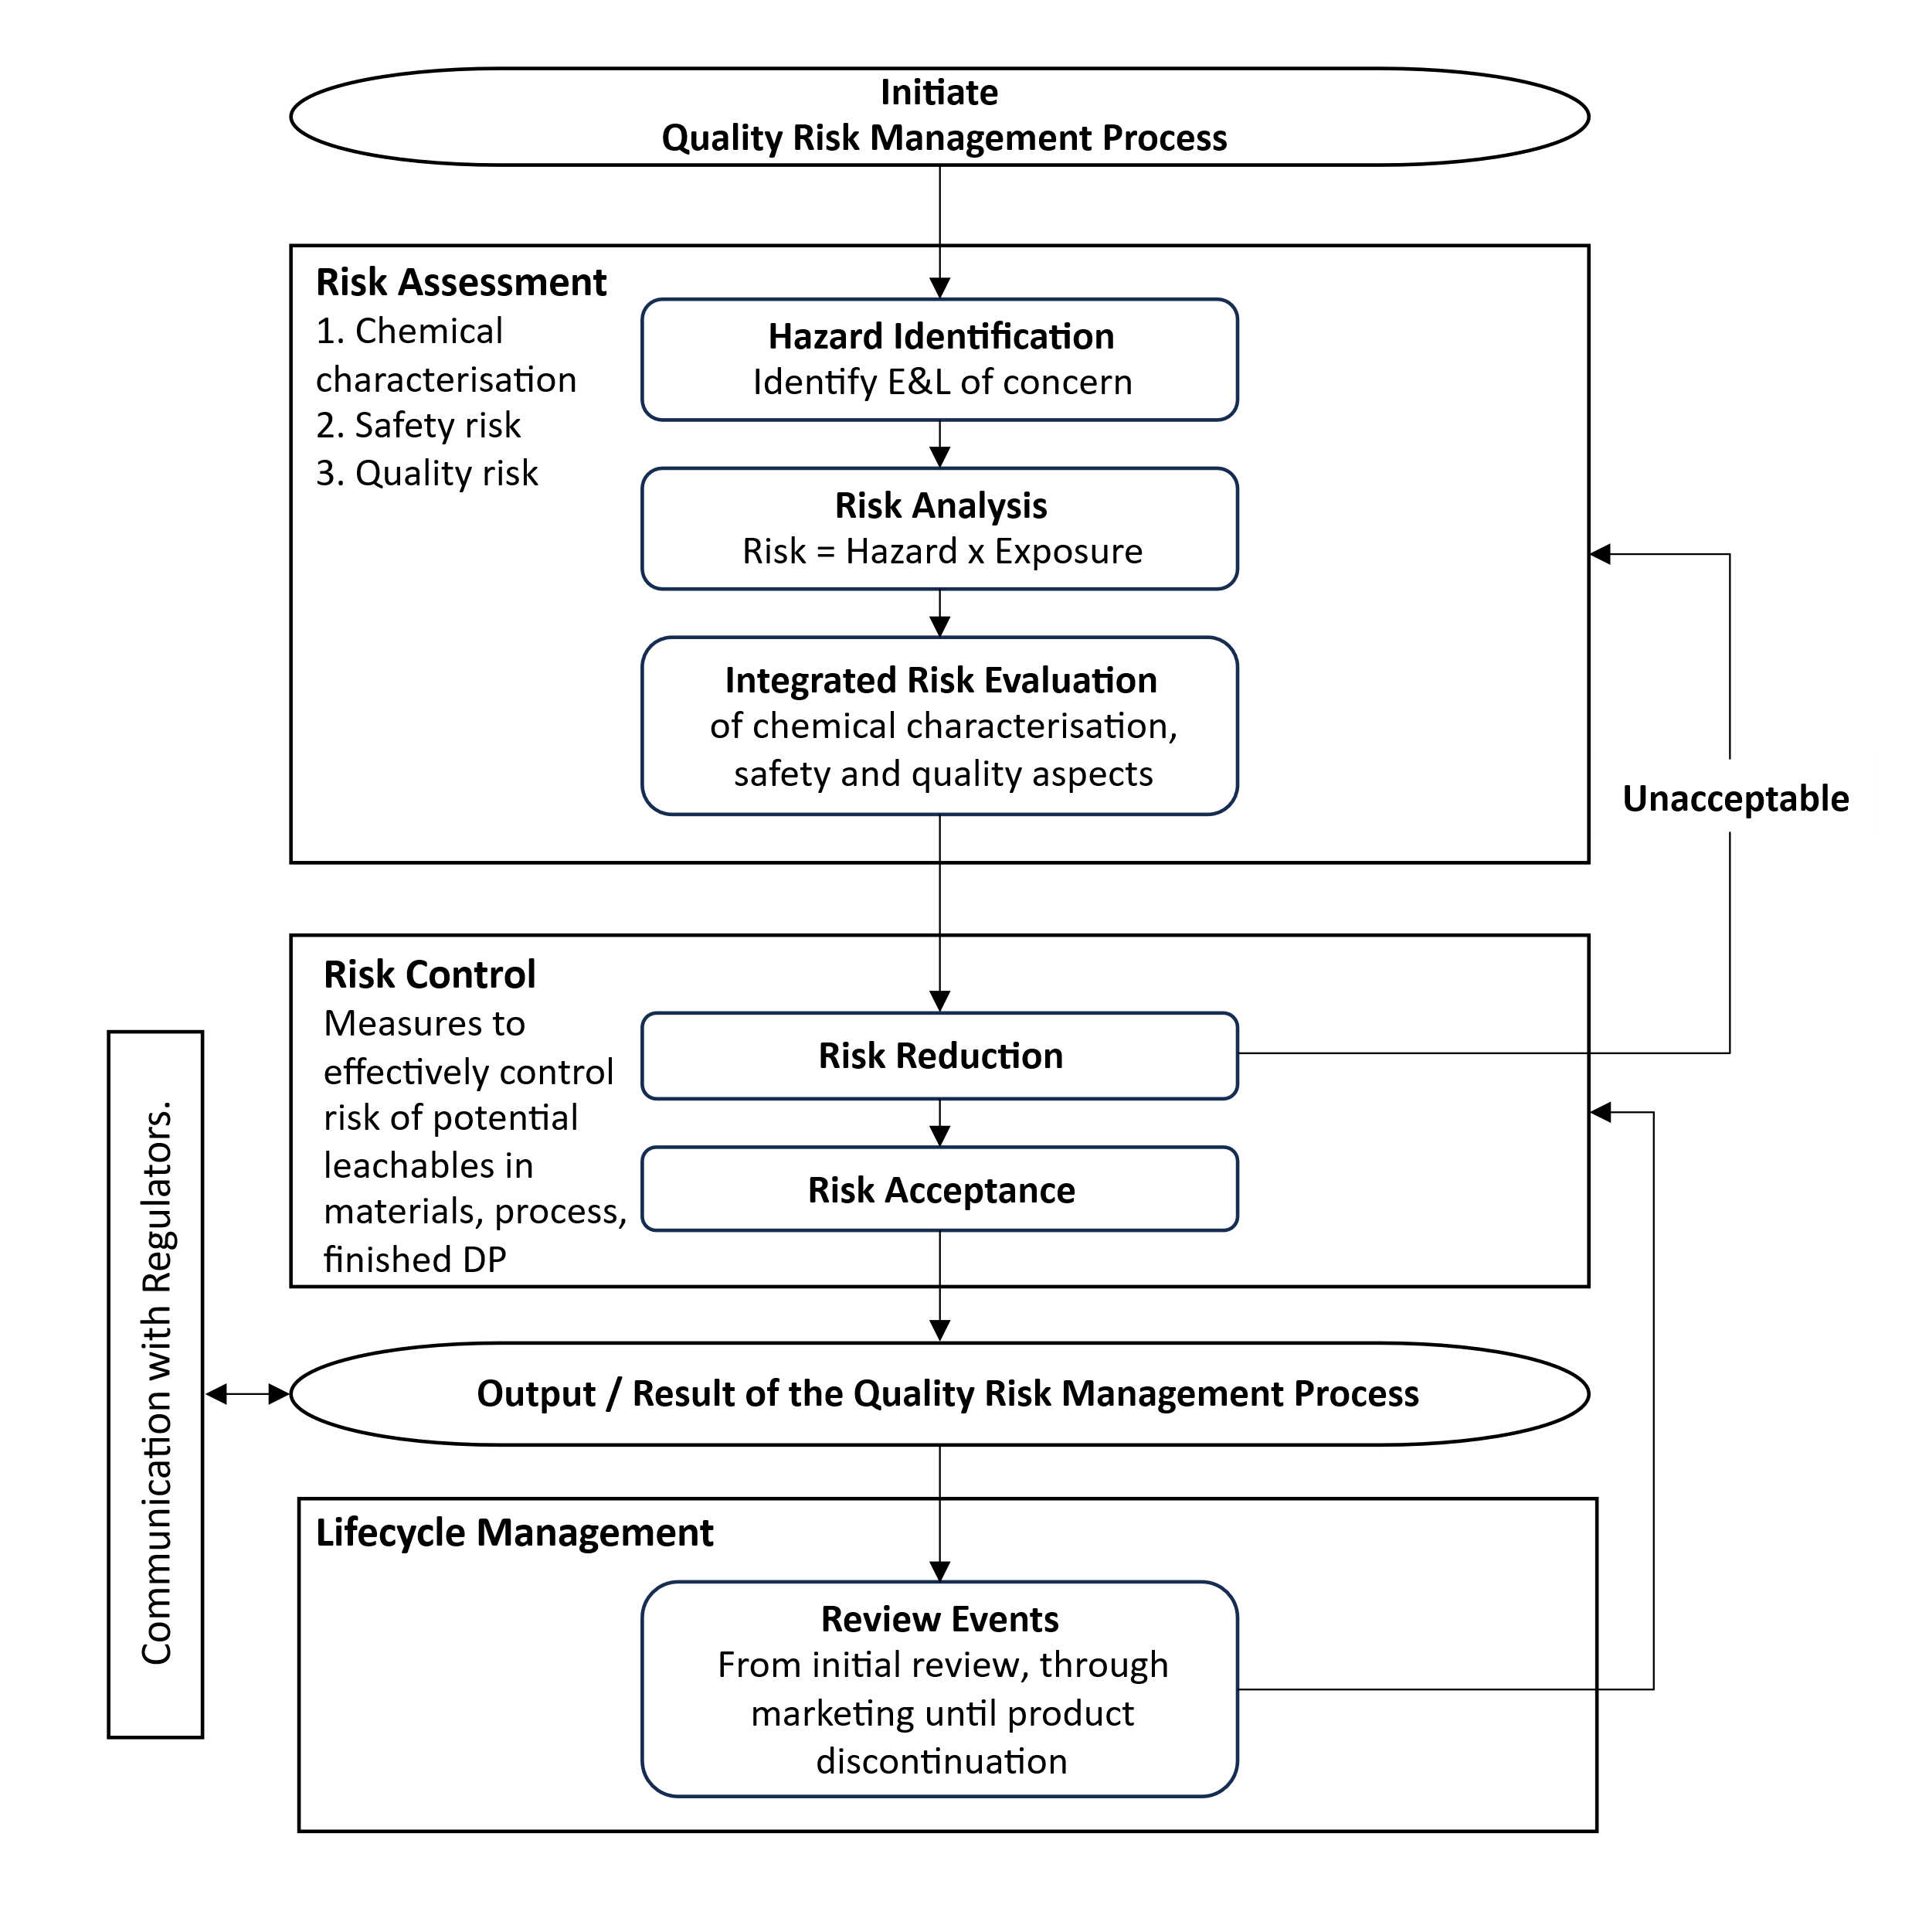
The quality risk management process for E&L warrants a holistic strategy, leveraging prior knowledge and a thorough understanding of the desirable and critical attributes for the manufacturing/packaging components and drug product, as well as the manufacturing and storage conditions. Close collaboration between the analytical chemist(s) and safety expert(s) is essential for knowledge sharing and development of the E&L quality risk management process. A Quality Risk Management Process should be initiated with every product, each with its own Risk Assessment, Risk Control and Lifecycle Management process.

Risk Matrix as a Multifactorial Concept
For the overall risk assessment and control of leachables, it is important to consider the multidimensional nature of risk, entailing both pharmaceutical quality and safety aspects. With respect to pharmaceutical quality, important dimensions include:
- The potential for interaction between manufacturing equipment or packaging component and the formulation,
- The chemical and physical properties of the equipment or component that likely contribute to leachables, and pre-treatment of components prior to use,
- The manufacturing and storage conditions, including but not limited to, surface area to solution volume ratio, temperature, duration of contact, proximity of the downstream removal steps and their capacity to deplete potential leachables.
- The leaching propensity of the formulation, including but not limited to API, pH, organic co-solvents and surfactant/chelating agents.
Safety assessment dimensions relate to the potential harms posed by leachables, inclusive of exposure-related factors such as the risk impact of the route(s) of administration, pertinent patient population(s), maximal dosing, dosing frequency and/or intervals, and maximum potential treatment duration in a lifetime.
The relative risks associated with various dimensions (not all inclusive) are shown in Figure 2. The overall risk of a drug product is determined by taking all those dimensions into consideration.

Figure 2: Overview on Aspects to Consider for Risk Matrix
CSF = Cerebrospinal fluid; DP = Drug product; IM = Intramuscular; IV = Intravenous; SC = Subcutaneous
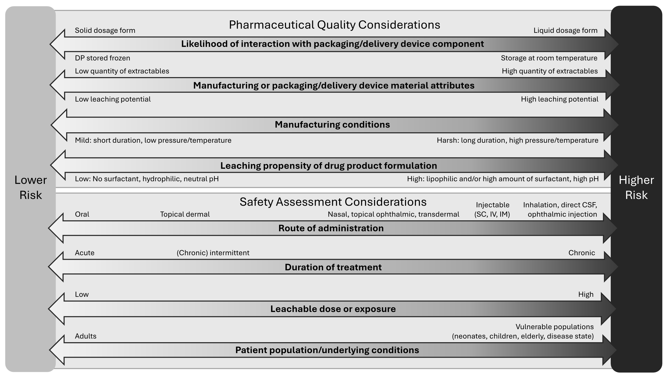
Depending on the anticipated risk and leveraging prior knowledge, various approaches can be adopted ranging from compliance with relevant food-contact safety or pharmacopeial standards/regulations to more extensive E&L characterization and safety risk assessment (See Appendix 1). For oral drug products, compliance with relevant regional food-contact safety regulations may be sufficient to support the safety and quality of polymeric manufacturing equipment/systems and container closure systems if adequately justified (e.g., proposed use is consistent with regional regulations for food contact use, the leaching propensity of the drug product is similar or less than those listed in a referenced regional regulation, and all specified testing results meet acceptance criteria). For all other drug products, or for oral products that do not comply with the regulations for food contact in terms of composition, specification, and in-use limitations, extractable/leachable assessments are typically warranted.
The risk matrix and factors described above highlight the complexity of the risks associated with a leachables assessment. Understanding the respective risk level of the corresponding factors is part of the risk assessment process and may inform manufacturing and packaging components selection as well as the development of an overall risk assessment/control strategy.

Risk Assessment
Based on the descriptions of the Risk Management Process (Figure 1, Section 3.1), the Multidimensional Risk Matrix (Figure 2, Section 3.2) and the Typical Workflows for E&L risk assessment and risk control (Figures 4 and 5, Appendix 1) risk assessment can be summarized in three basic steps:
- Step 1 - Hazard Identification: Identify potential leachables that may migrate into the drug product from direct (e.g., manufacturing components/systems, container/closure systems and delivery devices components) or indirect (e.g., secondary packaging, ink or adhesives on labels particularly for semi-permeable components) contact surfaces based upon prior knowledge (experience with component, prior testing, etc.) and/or extractables and leachables testing.
- Step 2 - Risk Analysis: Quantitate the potential occurrence of leachables in the drug product and assess the patient exposure to leachables.
- Step 3 – Integrated Risk Evaluation: Evaluate the potential risk to impact product quality, safety and efficacy to determine if the selected manufacturing components/systems and container/closure systems are considered qualified for the intended use.

Risk Control
If the comprehensive risk assessment indicates risk mitigation is needed, measures may include, but are not limited to, change of components/suppliers, pre-wash of components, pre-flushing of manufacturing equipment, and adding additional purification/isolation step(s). The adequacy of the mitigation measures ultimately implemented should be confirmed/verified via extractable and/or leachable studies.
Once the components are qualified for the intended use, a control strategy should be implemented. This comprises, but is not limited, to routine GMP practices which are imperative for component quality controls. A control strategy should be in place to:
- Establish adequate acceptance quality control including acceptance criteria, analytical procedures, and sampling plan for components as appropriate.
- Establish appropriate quality agreement with component venders including component lifecycle quality controls regarding any composition and/or fabrication process changes that might have impact on the extractable profiles.
See Appendix 1 for typical workflows for E&L risk assessment and risk control, including component qualifications for manufacturing components/systems (Figure 4, Appendix 1) and for packaging and delivery device components (Figure 5, Appendix 1). Typically, extractable and leachable studies should be conducted for packaging and delivery device components. Under certain circumstances alternative approaches may be proposed with proper justifications.
The principles and practices used for identifying risk and developing mitigation strategies to address safety concerns associated with packaging and delivery device components are also applicable to formulation contacting manufacturing equipment components made of polymeric materials. Extractables studies should therefore be designed to represent the worst-case scenario of the manufacturing conditions (e.g., smallest scale with longest contact durations, highest temperature and pressure). It is recognized that the potential for leachables in a drug product originating from the manufacturing components/systems is lower than that from the packaging and delivery components, due to relatively shorter contacting time with the formulation and larger solution volume to surface area ratio. Leachables introduced in upstream manufacturing process steps might be able to be purged through downstream steps, e.g. purification/polish, lowering the risk for leachables ending up in the final drug product. These factors should be taken into consideration for manufacturing equipment selection and qualification, as well as quality investigations.
For manufacturing components/systems, the leachables risk may be considered minimal and acceptable when all extractables peaks are at or below the Analytical Evaluation Threshold (AET) applicable to the drug product and no Class 1 leachables are observed (see Section 5). The analytical procedures used in extraction studies should comply with the criteria provided in Section 4.3.
In cases where manufacturing components/systems extractables are observed in concentrations above the AET, an identification of those extractables and quantification of the concentrations may be conducted to mitigate the leachables risk as long as the quantification of extractables is performed against appropriate reference standards of the same identity as the identified extractables. However, if authentic reference standards do not exist, compounds with a similar analytical response can be employed. If extractables concentrations quantified in this manner are below the relevant acceptable safety level (see Section 6), then the safety concern associated with leachables risk is considered negligible. As an alternative to qualification of extractables from manufacturing equipment at concentrations above the AET, a safety assessment of leachables may be performed.
For a packaging component/system an abbreviated data package may be considered when patient safety risk can be adequately mitigated by prior knowledge, (e.g. established extractable/leachable correlation, similar drug product with similar leaching propensity to approved drug product formulation), or no/few extractables detected above the AET and below their applicable safety threshold (such as Class 3 leachables; See Section 6). Table A.1.2 (Appendix 1) provides examples where the overall risk is considered low, in relation to Figure 2 (Section 3.2), and an abbreviated data package may be warranted with adequate justification. When an abbreviated data package is proposed, communications with relevant regional Regulatory Agency/Health Authority is recommended to align on approach.
If identified extractables are likely to chemically transform into compounds with a higher safety risk (i.e. through chemical degradation and/or interaction with formulation components to generate compounds with a higher safety risk), or if not all extractable peaks above the applicable AET can be adequately identified and/or quantified, a leachable study should be conducted to address these concerns and demonstrate acceptability of the components.

Special Considerations
When multiple manufacturing components, especially those constructed with the same or similar material are used, the cumulative leachables risk should be assessed.
Quality risk assessment and derived control strategies, when appropriate, should also encompass potential leachables from a container used to store a liquid or semi-solid drug substance.
Although minimal leaching occurs in the frozen state, the potential for leaching from storage component/system should be evaluated before freezing and after thawing.
In addition, for biological and biotechnology-derived products risk identification and mitigation may also include:
- Evaluation of the potential interactions between reactive leachables and formulation components that may lead to potentially adverse impact on product quality, safety, and/or efficacy. If impacts to critical quality attributes of the product by known reactive leachables are identified, potential mechanisms of chemical modification should be considered (such as denaturation, aggregation or degradation).
- For manufacturing of drug substance, leachables may be removed during the last purification step. Therefore, the quality risk assessment will typically focus on subsequent manufacturing processes.

Documentation and Compliance
Registration applications should include the justification for the extractable/leachable studies conducted, the associated study reports, the safety assessment of substances above the AET and any requisite risk control strategy. Extractables and leachables studies conducted to support the acceptability of manufacturing and packaging components/systems should be included in filing submissions (as described in ICH M4Q) as applicable. Adequate leachable data should be provided to address safety and quality concerns throughout the drug product’s shelf life. It is generally acceptable to submit leachable study results aligned with available stability data, with the provision to submit additional data post-authorization, subject to prior concurrence with the relevant regional regulatory authority. The quality risk assessment as defined in Section 3.3 of this guidance should be conducted on single-use and multi-use manufacturing components/systems, primary packaging components and delivery device components. For semi-permeable packaging materials, secondary packaging should also be evaluated as applicable.
A list of extractables and leachables studies conducted should be included along with an assessment report which will typically include analytical method and extraction condition selections along with justifications (solvents, temperature, duration, surface/volume ratio, etc.) for extractables studies and a description of the sample preparation and analytical procedures for leachables studies. In addition, the quantification procedure(s) should be described including the suitability of the procedures used for quantification (e.g., limit of detection (LOD), limit of quantification (LOQ), specificity, linearity, accuracy, and repeatability). All extractables and leachables peaks above the AET (see Section 5) should be included in the filing submission with chemical name, structure, CAS Registry Number (if available) and observed level. For leachables (or extractables when such testing is used for qualification), safety risk assessment as described in Section 6 should be included.
In addition to the quality risk assessment, a leachables to extractables correlation should be included in the registration application, as appropriate (refer to Section 4.6). Finally, the adequacy of any proposed mitigation measures (for example prewashing of the packaging and delivery components/system or pre-flushing of the manufacturing components/systems) should be demonstrated by data collected before and after implementation.

Risk Review / Lifecyle Management
This section describes the types of changes that might necessitate re-evaluation of the leachable profile during the lifecycle of the drug. The following is a non-exhaustive list of potential changes and an explanation of how these represent a potential to impact the patient leachable exposure. As such, these changes should be considered and justified scientifically using new studies and/or existing information sources.
New Information: If new data and/or information on a material pertinent to its suitability for use indicates a cause for concern and/or if new patient safety information for a leachable becomes available, an updated assessment may be warranted.
Changes to a drug product formulation: Changes to the drug product may cause different leachables from the existing formulation contacting manufacturing components/systems and/or primary packaging and/or delivery device components. For example, changes to excipients/surfactants composition or concentrations can affect both the composition and amount of leachables.
Changes to container closure system, delivery device, or manufacturing components/systems that contact drug substance and/or drug product: When there are known changes such as the composition, supplier, manufacturing process, geometry or pretreatment of materials contacting the drug substance (mainly for liquids and/or biologics) or drug product during the shelf-life of the drug, there is a potential for an altered leachable profile. In addition, for some products there may be a potential for non-direct packaging components to contribute potential leachables to the drug product.
Changes to a manufacturing process: Changes to process conditions may cause different leachables or different amounts of leachables from the existing formulation contact material. For example, change in solvent system, duration, temperature, pressure, pH, cleaning/sterilization process, surface area/volume ratio, pre-operation preparation (e.g., flushing), amongst others can affect both the composition and amount of leachables.
Changes that might affect patient exposure: Changes such as the posology of the drug, duration of treatment, route of administration and patient population (i.e., geriatric/pediatric) have the potential to change estimates of patient exposure to previously identified leachables, which may all affect the fundamental assumptions made in the exposure assessment and toxicological risk assessment of leachables.
Changes in indication that might affect patient benefit:risk: e.g. oncology to rheumatological disorders.

CHEMICAL TESTING AND ASSESSMENT

Prior Knowledge
Prior knowledge may comprise information useful to obtain before performing chemical testing, including information available from a supplier and any relevant information with regard to other drug products and processes. This information may include:
- composition (e.g., base polymer and copolymer, any known additives such as plasticizers, processing aids, catalysts, antioxidants)
- food contact compliance
- statements indicating particular (e.g., non-authorized) compounds have not been intentionally added
- compendial testing
- any available extractables studies
- biological reactivity testing
- processing or pretreatment steps (e.g., sterilization, cleaning, flushing, siliconization, surface treatments)
- prior use history, including any historical use with other similar drug products, process and/or contact conditions

Component Selection
A pharmaceutical product manufacturer is responsible for establishing requirements in alignment with regulatory expectations for the manufacturing, packaging, storage, and delivery of a unique drug product safely and effectively to an intended patient population. The level of risk for a particular material or component is relevant to the potential for interaction with the dosage form. For example, components that interact with dosage forms exhibiting a greater propensity for leaching (e.g., liquids) may be considered of higher risk than components that interact with dosage forms which exhibit a minimal propensity for leaching (e.g., non-lyophilized solids). The information obtained from the supplier (e.g., extractables report, compliance with compendial requirements) may be supplemented with additional testing appropriate for conducting a risk assessment and developing extractables/leachables procedures to demonstrate acceptable component selection. See Table A.2.1 (in Appendix 2) for a summary of extractable, leachable and simulated leachable studies.

Extractable Study
An extractable study is a process by which chemical entities are extracted from a test article. An adequate extractables study incorporates solvents and extraction conditions relevant to the anticipated leaching propensity of the drug product formulation under the worst-case scenario of manufacturing or storage conditions and employs multiple complementary analytical techniques to establish a comprehensive extractables profile. Key characteristics of an adequate extraction study include:
- Establishment and application of a drug product-specific AET to indicate extractable chemical entities to be identified and treated as potential leachables. Testing is performed on components or an assembled system including any processing and treatment (e.g., sterilization, molding and fabrication conditions, cleaning, siliconization) that would be representative of the final, finished component or system as intended for use
- Proper extraction media selection, including appropriate solvents of varying pH and polarity relevant to and representative of the drug product formulation (e.g. excipients, surfactants)
- Represents the drug product specific worst-case scenario for leachables occurring during manufacturing or arising from packaging components/systems during shelf life (e.g., contact area, temperature, duration)
- The analytical procedures used are adequately qualified at a level commensurate with the purpose of the extraction study
- Includes appropriate analytical procedures for volatile, semi-volatile, and non-volatile organic extractables and elemental extractables
- The extractables report describes details on analytical procedures
Specific targeted tests for potential Class 1 leachables (see Section 6.2 Leachables Classification) should be performed based on the understanding of the material of construction and quality; risk analysis should be performed as appropriate. Analysis of potential Class 1 leachables should follow the description of a quantitative extractables study (Section 4.3.2) or leachables study (Section 4.4).

Semi-Quantitative Extractables Study
A semi-quantitative extractables study may be appropriate in scenarios where a leachables study will subsequently be conducted to establish the acceptability of materials for intended use. The purpose of a semi-quantitative extractables study is to understand which extractables can be present as leachables in the drug product. Key characteristics of the semi-quantitative extractables study include:
- Analytical procedures that are qualified using several relevant standard compounds typically observed as extractables or leachables.
- Use of analytical uncertainty factor (UF; Section 5.1) in the calculation of the drug product-specific AET.
- Quantification of observed extractables against relevant standard compounds.
Semi-quantitative extractables observed above the AET can subsequently be used as targets for a quantitative extractables study or a leachables study.

Quantitative Extractables Study
To support qualification of manufacturing components/systems and certain low-risk packaging components/systems scenarios (Refer to Appendix 1 Table A.1.1 and A.1.2, respectively) for which extractables were observed at a level above the AET during the semi-quantitative extractables study, a quantitative extractables study to quantify these specific extractables would be warranted. Key characteristics of quantitative extractables study include:
- Confirmed identification of extractables above the AET.
- Quantification of the identified extractables above the AET using standards with identical or similar analytical response.
- The analytical procedure used for quantifying the identified extractables above the AET should be qualified for the specific standard compound.
If the amount of an adequately identified and quantified extractable exceeds its qualification limit (e.g., applicable safety threshold or permitted daily exposure (PDE)), a leachables study is warranted to demonstrate the compound as a leachable remains below its qualification limit. In addition, a leachables study can also be used to assess the quality risk for extractables above the AET when those extractables cannot be identified with confirmed identities.

Leachables Study
Leachables studies intended to support drug product registration are designed to represent the actual manufacturing conditions and intended storage conditions throughout the proposed shelf-life and in-use period. During the shelf life and in-use period, multiple time points should be evaluated to characterize trending of leachables to estimate maximal occurrence. The leachables assessment for the container closure system is performed on the actual drug product during stability storage and may include accelerated storage conditions. For a container closure system, the study should involve multiple primary drug product stability and/or development batches manufactured with the actual packaging and delivery system intended for use with the commercial product. If multiple batches are not available, alternative approaches may be proposed with justification. Use of the same lots of components used in extractables assessments potentially enables a more meaningful correlation between extractables and leachables. Analytical procedures for specific, targeted leachables should be appropriately validated to establish that they are sensitive, selective, accurate, and precise. Non-targeted screening procedures should also be used and employ appropriate analytical techniques to facilitate detection of any unanticipated degradation of leachables, leachables from secondary packaging, and/or interaction products. The non-targeted screening study should include the application of an AET (See Section 5) to indicate a level above which leachable chemical entities should be identified, quantified, and reported for toxicological assessment.
Reference standards, if available, are preferred as they facilitate more accurate and precise quantitation of target leachables that may be present as actual drug product leachables when they are used to produce either proper response factors or calibration curves; in which case the analytical accuracy and precision is high.

Simulated Leachable Study
Circumstances may exist when performing a drug product leachables study is not technically feasible despite thorough due diligence which may include systematic investigation of multiple diverse sample preparation techniques coupled with highly sensitive and selective analytical methods, techniques and instrumentation. Such circumstances may include challenging detection or quantification thresholds associated with large volume parenterals (LVPs), significant analytical matrix interference inherent with complex drug product formulations, or a combination of such factors. In such situations, use of a simulation study to support actual drug product leachables evaluation may be justifiable. For example, a simulation study could be performed to augment a leachables study to accomplish the objectives that cannot be obtained by leachables testing. In the case of a challenging AET (i.e., procedure LOQ > AET), the leachables study would be performed with relevant test procedure LOQ and a simulation study would be performed to fill in the gap between the LOQ and the AET. Alternatively, a simulation study could be used to replace a leachables study when, through thorough due diligence, it is established that performing the leachables study is impractical.
It is important to recognize that, regardless of how well the simulation study is designed and executed, its outcome will likely only approximate the results of a drug product leachable study and cannot fully replicate a true leachable profile of the drug product. For example, a simulation study cannot and will not address any potential interaction between leachables and the components of the drug product formulation components.
The simulation study is a surrogate study that reveals likely true leachables that would be detected if a leachables study could have been conducted. Thus, the simulated leachables detected above the simulation study’s drug product specific AET should be identified, quantified, and assessed for safety. As the goal of a simulation study is to obtain a simulated leachables profile that closely mimics the actual leachables profile generated by the drug product over its shelf-life, the simulation conditions and process used in the simulation study should closely match the drug product manufacturing/storage conditions used in a leachables study, with the intent of simulating the conditions experienced by the drug product during its manufacturing, shelf-life storage, and in-use (clinical) preparation. Furthermore, the simulation solvent should be chosen so that is has a similar propensity to leach as the drug product, and the simulated manufacturing process should be performed using worst-case conditions. Moreover, a simulation study can be accelerated versus drug product shelf storage conditions to mimic the outcome of a leachable study over the entire drug product shelf life with shorter duration.
As the intent of the simulation study is to augment or replace a leachables study, the simulation study must meet all the quality requirements for a leachables study, including test procedure qualification. When properly justified, use of a simulation study is an alternative to the recommended practice of performing leachables studies. Thus, the intended application, justification, and qualification of a simulated leaching study for a particular drug product should be based on a scientifically sound rationale with demonstration of due diligence supported by appropriate testing and experimentation. When considering the use of a simulation study, consultation with the relevant regional Regulatory Agency prior to implementation may be warranted.

Extractable and Leachable Correlation
The main purpose for generating extractables profiles is to characterize and assist selection of components, identify potential leachables, develop methods for targeted leachables, and correlate leachables and extractables. Leachables generally represent a subset of the extractables and the concentration of each leachable is typically below that of the corresponding extractable from a well conducted extractables study.
Once the E&L profiles above AET are available, it is recommended that a qualitative and quantitative correlation between the two be evaluated. A correlation between leachables and extractables may be established when actual drug product leachables can be comparatively linked qualitatively and quantitatively with extractables from corresponding extractables studies of components or systems. Correlating leachables with extractables may support a justification for the use of routine extractables testing of components as an alternative to routine leachables testing during stability studies when appropriate for high-risk drug products, change control, and ongoing quality control. Potential explanations for leachables that were not detected or detected at higher levels than suggested by the extraction study conditions could include inadequate design and/or execution of the extractables study, degradation of leachables to form new compounds, interaction products of leachables with API and/or excipients, chemicals migrated from packaging, and/or new leachables resulting from materials change due to aging (e.g., exposure to UV light, heat, oxygen) during shelf-life storage. Though the E&L correlation is valuable and informative for the quality risk assessment and may be leveraged for component selection and life-cycle management decisions, it is the leachables profile that ultimately drives patient safety risk evaluations and component acceptability.
Any changes occurring during the product life-cycle significantly altering the extractable/leachable profiles should prompt re-evaluation of the extractable/leachable profiles and their correlation. If a specific leachable is observed in the drug product during stability studies at a level significantly greater than anticipated from the calculated potential maximum level of the leachable as established with the extraction study conducted on the same component/system lots as were used for the drug product stability batches, it can indicate that the extraction study was incomplete and it may not be possible to establish a meaningful leachables to extractables correlation for that particular leachable.

ANALYTICAL EVALUATION THRESHOLD
The AET is not a control threshold, but rather a threshold corresponding to a concentration above which extractables or leachables should be identified, quantitated, and reported for safety assessment, forming the foundation of the overall E&L risk assessment and control strategy. The ICH guidelines on impurities in new drug substances (ICH Q3A) and impurities in new drug products (ICH Q3B), describe a series of predetermined thresholds based upon maximum daily dosing that are intended to provide adequate control over critical quality attributes that may impact the safety and efficacy of the drug product over the course of the product shelf-life. In contrast, this guideline recommends incorporation of a Safety Concern Threshold (SCT; see Section 6 Safety Assessment) to first establish a study-specific AET.
An extraction study should include the establishment and application of an AET to indicate extractable chemical entities to be detected, identified and reported as potential leachables for the drug product. For a leachable study, the AET is established at a concentration above which compounds should be identified and quantitated to enable appropriate safety assessment. For Class 1 leachables (See Appendix 4, Table A.4.1), the compound-specific safety limit, instead of a product-specific SCT, should be used for quantification.
Derivation of the study-specific AET depends on dosing considerations (e.g., maximum dose level, frequency of dosing, and duration of treatment). The AET may be expressed using various units of measure depending on the type of study (extractable vs leachable) and what is being evaluated. For example, weight of extractable per weight of component material (e.g., µg/g) or weight of extractable per extraction solution volume (e.g., µg/mL) are commonly used units for extractables in solutions. For leachables studies, weight of leachables per packaging or delivery component/system (e.g., µg/component, µg/mL, µg/g, ppm) may be used to represent the leachables AET based on the entire container closure system or set of manufacturing components. Regardless of the units used to express the AET, they will all equate to an equivalent potential patient dose for a given study. Example AET calculations are presented in Appendix 3.

Analytical Uncertainty Factor
When an AET is used in semi-quantitative analytical methods, an appropriate uncertainty factor should be applied to account for potential underestimation of analyte concentrations due to differences in response factors between analytes and the reference standard.
The determination of the appropriate magnitude for the analytical uncertainty factor(s) in a given extractable/leachable study depends on the prior knowledge and understanding of the materials of construction, the possible chemical structure of the potential extractables/leachables, the availability of the reference standards covering the range of response factors, and the limitations of the analytical methods.
Under certain circumstances an acceptable approach is to multiply an uncertainty factor (UF) of no greater than 0.5. Alternatively, an uncertainty factor can be derived from statistical analysis of appropriately constituted response factor database of relevant reference compounds. Justification of UF applied should be included in the extractable/leachable study report.

SAFETY ASSESSMENT

General Principles
A risk-based scientific evaluation is needed to provide confidence that any potential leachables in the drug product are at levels where they pose negligible risk to the patient. Within this overall risk-based evaluation, the focus of the safety assessment is the toxicological evaluation of leachables in the drug product exceeding a predefined SCT for that drug product. Within this context, the SCT is considered the threshold below which a leachable would have an exposure so low as to present negligible mutagenic and non-mutagenic toxicity concerns. The outcome of the safety assessment can be used to determine if levels of Class 1 leachables from a material are considered acceptable and may be used to set specifications for leachables in the drug product if needed.
Since the SCT is defined to be protective of both mutagenic and non-mutagenic effects, it must consider both mutagenicity concerns and concerns related to alternative toxicity endpoints and is based on whichever is more limiting with respect to exposure. As such, in addition to amount of exposure, the SCT dependent on both route and duration of exposure. For mutagenicity concerns, the Threshold of Toxicological Concern (TTC) as described in ICH M7 is considered applicable. For non-mutagenic toxicity endpoints, a Qualification Threshold (QT) is used in this guideline and may be considered as a dose at which potential non-mutagenic toxic effects are negligible. Subsequently, the SCT is the lowest value of either the TTC or QT for a specific drug product, considering route and potential duration of exposure. Oral and parenteral QT values have been derived by review of approximately 330 potential leachable permitted daily exposures (PDEs). An overview of these systemic safety thresholds (expressed in µg/day) for oral, parenteral, dermal/transdermal and inhalation routes of exposure, are provided in Table 1. In addition, local toxicity thresholds for leachable concentrations in drug products for topical ophthalmic, subcutaneous/intradermal, dermal/transdermal and inhalation routes of exposure are presented. For other routes of administration, the concepts described in this guideline may be used to determine acceptable exposure levels.

Table 1: Systemic and Local Toxicity Thresholds
Systemic Toxicity Thresholds
Exposure Duration |  | Oral |  |  |  | Parenteral, Dermal/Transdermal, Inhalation
 |  | TTC |  | QT |  | TTC | QT
> 10 years |  | 1.5 μg/day |  | 48 μg/day |  | 1.5 μg/day | 12 μg/day
> 1 to 10 Years |  | 10 μg/day |  |  |  | 10 μg/day
> 1 Month to 1 Year |  | 20 μg/day |  |  |  | 20 μg/day
≤ 1 Month |  | 120 μg/day |  | 136 μg/day |  | 120 μg/day | 26 μg/day
Local Toxicity Thresholds
Topical Ophthalmic | Subcutaneous and Intradermal |  | Dermal and Transdermal |  | Intracerebral, Intrathecal, Epidural and Intraocular |  |  | Inhalation
20 ppm | 50 ppm |  | 500 ppm |  | Compound-specific evaluation  (see Section 6.4) |  |  | 5 µg/day
QT values for inhalation and dermal/transdermal routes have been established based upon parenteral QT in lieu of available PDE values.

Leachables Classification
Potential leachables from various materials encompass a large variety of chemicals, and thus toxicological characteristics. To provide a pragmatic, risk-based approach to leachables safety assessment, certain compounds need to be controlled at levels that are lower than the established qualification threshold due to their potential for highly potent toxicity. Such chemicals are categorized as Class 1 leachables in the current guideline. For mutagenic carcinogens, the Cohort of Concern as defined in ICH M7 and ICH M7 Class 1 impurities with an AI below 1.5 µg/day are considered Class 1 leachables. Similarly, there are some compounds, such as bisphenol A (BPA) or benzo(a)pyrene, that may have potent non-mutagenic toxicity concerns that may theoretically be associated with a greater than negligible patient safety risk at or below the drug product QT value. For such Class 1 leachables, it is considered most practical to avoid the use of materials which may leach such compounds (see Section 5). However, if the use of such materials or components is considered unavoidable, a compound-specific safety limit for these substances should be used.
Class 3 leachables are compounds established to have relatively low potency for systemic toxicity with derived chronic parenteral PDEs in excess of the levels at which leachables are typically observed (i.e., PDE ≥ 1 mg/day using the methodology described in Appendix 5). Class 3 leachables would not require further safety qualification if observed at daily exposure levels < 1 mg/day. In between these two classes are compounds with a toxicity potential that may be relevant at levels commonly encountered for leachables (Class 2 leachables). Appendix 4 provides an overview of these three leachable classes.

Safety Assessment Process
Organic leachables exceeding the AET should be identified, quantified, and reported for safety risk assessment. Acceptability of partial or incomplete elucidation of the compound structure should be justified from an analytical perspective. If toxicologically justified, partial elucidation providing tentative structures may inform a safety assessment in certain cases. The general process for safety assessment of leachables is presented in a flowchart (Figure 3) and includes an assessment of both mutagenicity and general toxicity concerns.
Figure 3: Safety Assessment Process for Leachables Using Safety Evaluation Thresholds
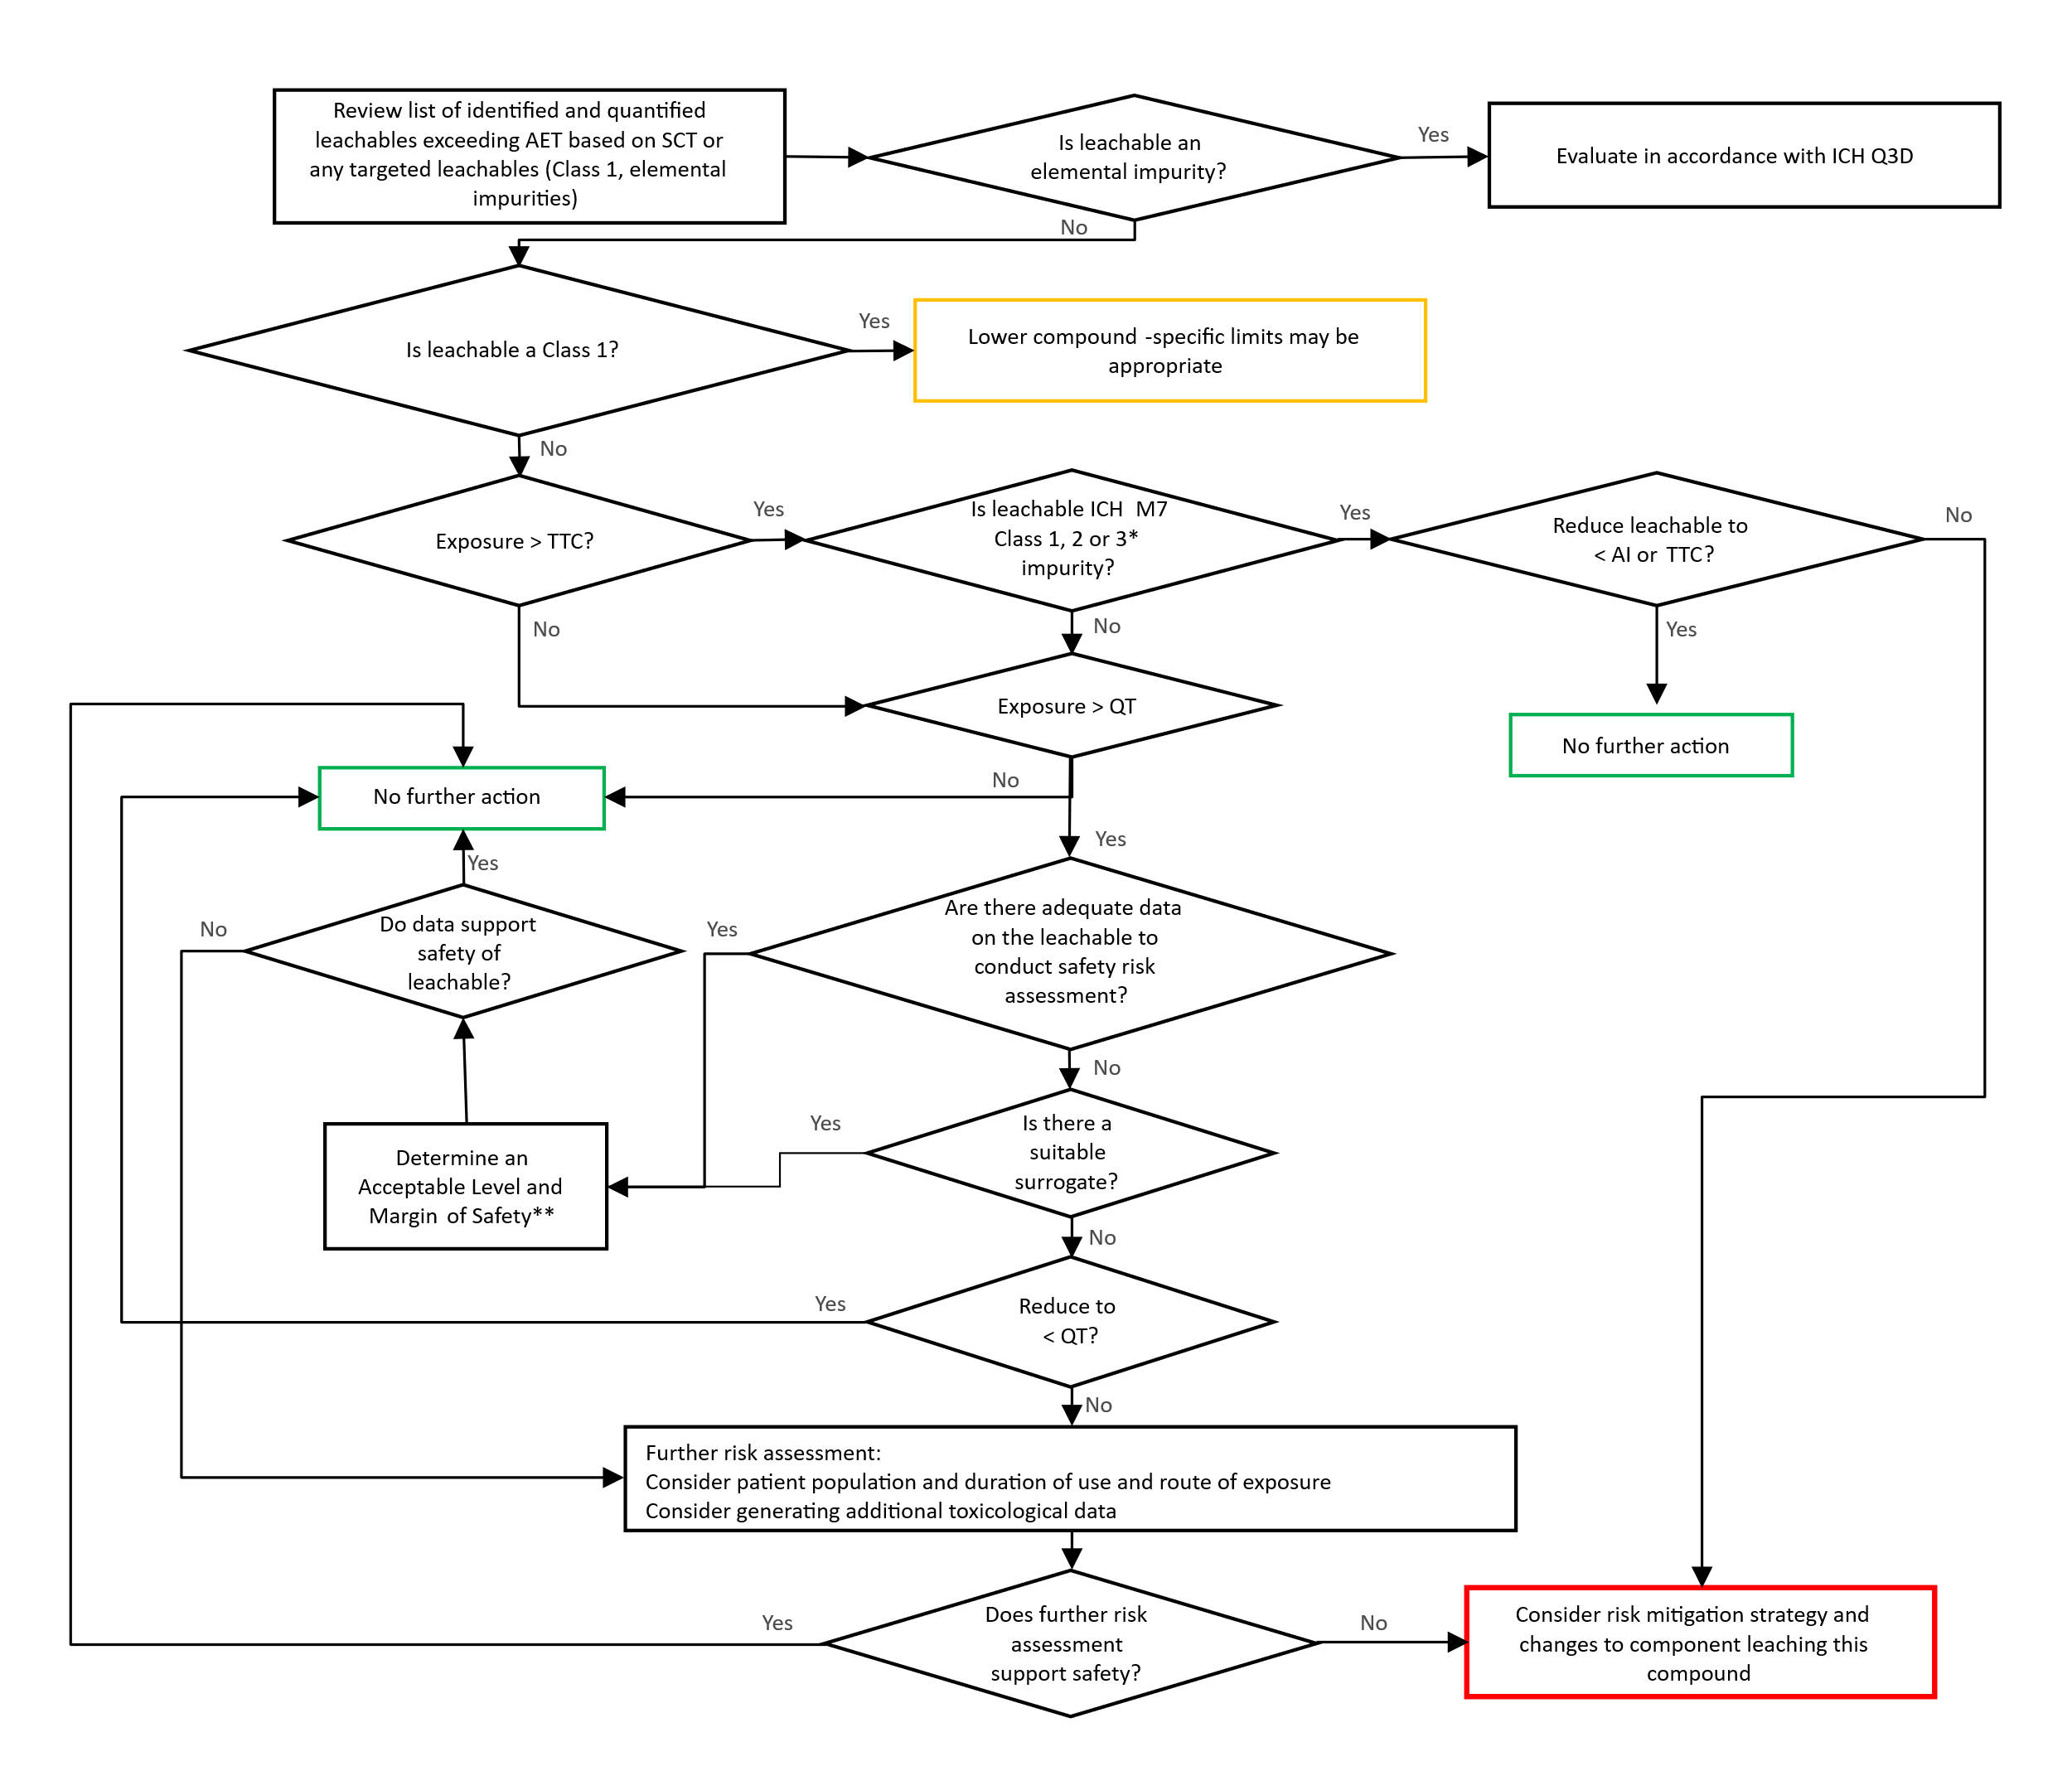
* As described in ICH M7.
** If daily exposure to leachable is >1 mg/day, genotoxicity studies should be considered, as recommended in ICH Q3A and ICH Q3B (e.g., bacterial mutagenicity study and in vitro chromosomal aberration assay).
Potential Class 1 leachables should ideally be identified and avoided during materials and component selection. However, if such compounds cannot be avoided, lower compound-specific thresholds and specifications to adequately control their presence as leachables should be implemented as an initial step in the process. Subsequently, all leachables above the TTC applicable to the drug product should be evaluated for mutagenic potential according to ICH M7. Leachables considered potentially mutagenic should be appropriately controlled within TTC limits unless de-risked by appropriate mutagenicity studies.
In addition to the mutagenicity assessment, all leachables above the applicable QT for the drug product should also be evaluated for general toxicity concerns. If adequate data are available to support the safety of the leachable at the maximal potential patient exposure, then no further toxicological assessment is needed (See Appendix 5 for further information). Conversely, if data do not sufficiently support the safety of the leachable, further action is needed to reduce the potential exposure to a known acceptable level (material replacement, etc.), generation of additional toxicological data to qualify the observed level, or a risk/benefit assessment providing justification of exposure at the observed level.
It should be noted that for leachables where adequate data to inform on the safety of the compound are not available, a read across approach using a highly similar compound(s) with toxicological data is encouraged. If suitable surrogate(s) can be identified that have sufficient data to support the safety of the observed leachable at the level observed, further safety risk assessment and/or studies can be avoided.
If the generation of novel toxicological data is considered necessary to support the safety of exposure to a leachable, New Approach Methodologies (NAMs) including in silico and in vitro models may be considered if appropriately justified. Otherwise, a toxicological qualification study(ies) as described in ICH Q3A and Q3B should be considered in order support safety assessment of the compound(s).

Route Specific Considerations and Special Cases (Local Toxicity Concerns)
Safety risk assessments for potential systemic toxicity are typically sufficient to support the safety of exposure to leachables. However, there are certain scenarios where potential local toxicity effects may be pertinent due to the potential for damage to vulnerable tissues related to the local concentration of a compound (e.g., pulmonary drug products, ophthalmic drug products, and intracerebral/intrathecal/epidural drug products). When relevant, the toxicological risk assessment should address the potential impact of a leachable on local tissue toxicity as well as factors that may potentially reduce such concerns (e.g., formulation and excipients, contact duration, recovery of tissue damage). Additionally, when potential local toxicity needs to be considered, the SCT used should be the lowest (on a daily exposure basis) of the mutagenic (i.e., TTC), non-mutagenic (i.e., QT), and local toxicity thresholds (pertinent concentration converted to a maximum daily exposure level).

Ophthalmic Drug Products
Ophthalmic products are often administered topically, while some products are injected directly into ocular tissues. There is a paucity of data to characterize the potential local toxicity of leachables when in contact with ocular tissues. Based on historical precedence, in the absence of a relevant database, a compound-specific risk assessment should be completed for topically administered products to justify the safety of a leachable when it exceeds a concentration of 20 ppm in the final to-be-marketed topical ophthalmic products. This concentration limit is not considered applicable to irrigation fluids that are in transient contact with ocular tissues. For products injected into ocular tissues no threshold is given. A qualitative safety assessment of any leachables present should be provided, since such leachables may be of relevance even when present at a concentration below 20 ppm.

Intracerebral, Intrathecal, Epidural Drug Products
Intracerebral, intrathecal, and epidural drug products may directly interact with vital central nervous system (CNS) tissues that have a limited capacity for repair following insult, yet there is a paucity of data to characterize the potential toxicity of compounds directly administered into or in close proximity to neuronal tissue. In vitro data suggest chemically induced biological effects can occur in the very low parts per billion (ppb) range for some compounds with known neurotoxicity. Therefore, a compound-specific risk assessment should consider local concentration of observed leachables and the potential local toxicity concerns on neuronal tissue (e.g., neurons, astrocytes, glia, myelin) including an assessment of the potential for a local inflammatory response.

Dermal Drug Products
With regard to any local toxicity effects, sensitization potential (see Section 6.4.4) is likely the most sensitive non-genotoxic endpoint when the leachable concerns a strong or extreme potency skin sensitizer. For High Potency Chemicals (HPC), a Dermal Sensitization Threshold (DST) of 1 µg/cm²/day has been derived. This threshold corresponds to 500 ppm in a dermal drug product, using the Cutaneous and Transcutaneous Concentration Limit (CTCL) calculation for conversion as described in ICH Q3D. Consequently, a local toxicity threshold corresponding to 500 ppm concentration in the product can be used for dermal products below which there is no need for local non-mutagenic toxicity evaluation including sensitization potential (See Table 1.).

Sensitization Potential
Sensitizers are compounds that may trigger hypersensitivity reactions after repeated exposure. The concern for these compounds is dependent on the sensitization potential of the compound, the route of exposure and the susceptibility of the individual exposed. Different types of hypersensitivity with multiple modes of action have been described for various routes of exposure; however, validated prediction models exist for the dermal route only. This guidance addresses the risk for induction of sensitization potential and provides local toxicity thresholds for this risk where appropriate. If patients are sensitized to a compound, elicitation of sensitization reactions may occur at lower thresholds.
Dermal exposure
Most data on sensitization potential have been obtained using the dermal route. Besides human data, in silico, in chemico, in vitro, and in vivo models have been developed and used to characterize the dermal sensitization potential of compounds. DSTs have been derived based on sensitization potency.1,2
Where an identified leachable is administered dermally below the DST for the relevant potency category, it can be concluded that no concern for dermal sensitization is expected, and no further action is required. If the DST is exceeded, available compound-specific data on sensitization potential should be evaluated. If no such data are available, or when these data raise concerns, risk mitigation measures need to be considered. These may include replacement of the component leaching the compound or reduction of the level of the leachable.
As transdermal drugs are applied to the skin as well, the same approach can be used to evaluate the risk for sensitization potential. For multi-day patches it is assumed that all leachables migrate within a day. A slower migration rate should be justified with data.
Inhalation exposure
Knowledge of the respiratory sensitization potential of a compound is primarily from human data. Currently, suitable non-clinical models for respiratory sensitization are not established for safety risk assessment. The modes of action for dermal and respiratory sensitizers show commonalities, but also deviate, especially after T-cell activation. Consequently, dermal sensitization data should not be used to estimate the risk for respiratory sensitization and no threshold for respiratory sensitization can be provided.
The respiratory tract is very sensitive to compounds with sensitizing (and irritating) properties³. Therefore, any compound with structural elements that may suggest sensitizing potential or irritation should be evaluated (e.g. isocyanates, nitriles, styrenes, short-chain aldehydes). If a compound is considered to be an irritant or have sensitizing potential, patient risk should be assessed on a case-by-case basis after evaluating the available information for the specific compound. Additionally, available clinical data should be evaluated for evidence of any adverse effects. If no concern is identified for irritancy or sensitization, a systemic toxicity QT aligned with parenteral, as presented in Table 1, is considered appropriate.
Parenteral Exposure
Regarding potential risk for sensitization, a distinction should be made between the subcutaneous/intradermal route and the intravenous/intramuscular/intraperitoneal routes of exposure. For the subcutaneous route, the drug is administered in the vicinity of the same tissues and cells (i.e., Langerhans cells) that are pivotal in triggering dermal sensitization. Especially, when the leachable is not readily distributed and remains for more extended periods in the subcutis, the same modes of action may be activated. Consequently, available data on dermal sensitization potential can be informative when evaluating the sensitization potential for leachables that are administered subcutaneously. Likewise for products administered intradermally, dermal sensitization data may be of relevance. In contrast, dermally applied compounds need to penetrate the skin barrier first. To account for this difference a ten-fold lower threshold for subcutaneous and intradermal products as compared to dermal products is considered justified, i.e., 50 ppm instead of 500 ppm.
Several types of systemic hypersensitivity (Type I-IV) are known, each having different modes of action. Type IV is dependent on hapten formation and thus shares some mechanistic aspects with dermal sensitization. However, contrary to dermal application, intramuscular and intravenous administered substances are rapidly distributed systemically, and large amounts are required to activate the immune system and induce sensitization. Since leachables are present at low concentrations in drug products, it is considered unlikely that sensitization potential will be of concern for drugs administered via intravenous or intramuscular injection.

Considerations for ICH S9 Products
For drug products within the scope of ICH S9, leachables should generally be identified according to the scientific principles outlined in Section 3 above. The safety risk assessment may be conducted according to the ‘Evaluation of Impurities’ Section in ICH S9. In this case, the TTC would not be applicable and the SCT would be defined by the QT. Risk assessment may be conducted with a focus on general safety for the intended patient population and is relevant for genotoxic APIs covered by ICH S9 Q&A, 2018.

Content of Safety Assessment
A safety assessment should be conducted for observed Class 1 leachables, Class 2 leachables detected at levels above the relevant SCT, and Class 3 leachables when present at levels above 1.0 mg/day. The safety assessment should provide sufficient information to conclude on the acceptability of the anticipated patient exposure levels. Further details on the information to be considered and the methodology for deriving an acceptable exposure level is provided in Appendix 5.

GLOSSARY
Analytical Evaluation Threshold (AET):
The threshold above which an extractable or leachable should be identified, quantified, and reported for safety assessment.
Chemical characterization:
The process of obtaining chemical information about the composition of an item such as pharmaceutical packaging and a pharmaceutical manufacturing component.
Component:
A single item, composed of one or more materials of construction, that serves a single purpose or performs a single and specific task.
Extraction:
The chemical or physical process of transferring constituents of a test article into an extraction medium.
Critical quality attribute:
A physical, chemical, biological or microbiological property or characteristic that should be within an appropriate limit, range, or distribution to ensure the desired product quality.
Drug product:
The dosage form in the final immediate packaging intended for marketing.
Drug substance:
The unformulated active pharmaceutical ingredient that may subsequently be formulated with excipients to produce the dosage form (or drug product).
Extractables Profile:
Qualitative or semi-quantitative/quantitative accounting of the extractables present in an extract.
Leachables Profile:
Qualitative and/or quantitative accounting of the leachables present in a drug product.
Lifecycle:
All phases in the life of a product from the initial development through marketing until the product’s discontinuation
Lowest-Observed (Adverse) Effect Level (LO(A)EL):
The lowest dose of substance in a study or group of studies that produces biologically significant increases in frequency or severity of any (adverse) effects in the exposed humans or animals.
Read-across:
A technique for predicting endpoint information for one substance by using data from the same endpoint from (an)other structurally-related substance(s).
Margin of Safety:
A correlation between the PDE of the specific leachable and actual patient intake based on the daily dose.
Materials of construction:
Individual materials used to construct a packaging or manufacturing component or system.
New drug product:
A pharmaceutical product type, for example, tablet, capsule, solution, cream, which has not previously been registered in a region or Member State, and which contains a drug ingredient generally, but not necessarily, in association with excipients.
No Observed (Adverse) Effect Level (NO(A)EL):
The highest concentration or amount of a leachable or extractable that does not cause any statistically or biologically significant (adverse) effects in the exposed population compared to a control group.
Permitted Daily Exposure (PDE):
The maximum acceptable intake per day of a leachable in pharmaceutical products per day (for a lifetime).
Point of Departure (PoD):
Starting point in the calculation of PDE of leachables; it can be derived from the human dose or appropriate animal study.
Qualification Threshold (QT):
Threshold above which a leachable should be qualified for potential non-mutagenic toxicity unless the leachable is identified as being Class 1.
Safety Concern Threshold (SCT):
Threshold at or below which a leachable would have a dose so low as to present negligible safety concerns from mutagenic and non-mutagenic toxic effects unless the leachable is identified as being a leachable of high concern.
Simulated Drug Product:
Matrix or solvent that mimics closely the leaching characteristics of the drug product formulation with respect to leaching propensity and solubility of leachables.
Substance (Compound, Chemical, Chemical Entity):
An association of different elements or chemical entities which have a definite chemical composition and distinct chemical properties.
System:
The sum of individual components (or assemblies) which together perform a specific function, such as manufacturing, delivery or storage/packaging.
Threshold of Toxicological Concern (TTC):
Threshold at or below which a leachable is not considered for safety assessment for mutagenic effects as described in ICH M7.

REFERENCES
International Conference on Harmonisation (2006). Q3A(R2): Impurities in New Drug Substances.
International Conference on Harmonisation (2006). Q3B(R2): Impurities in New Drug Products.
International Council for Harmonisation (2024). Q3C(R9): Guideline for Residual Solvents.
International Council for Harmonisation (2022). Q3D(R2): Guideline for Elemental Impurities.
International Council for Harmonisation (2023). M7(R2): Assessment and Control of DNA Reactive (Mutagenic) Impurities in Pharmaceuticals to Limit Potential Carcinogenic Risk.
International Council for Harmonisation (2023). Q9(R1): Quality Risk Management.
International Conference on Harmonisation (2009). S9: Nonclinical Evaluation for Anticancer Pharmaceuticals.
International Council for Harmonisation (2018). S9: Nonclinical Evaluation for Anticancer Pharmaceuticals Questions and Answers.

- Chilton ML, Api AM, Foster RS, Gerberick GF, Lavelle M, Macmillan DS, et al. Updating the Dermal Sensitisation Thresholds using an expanded dataset and an in silico expert system. Regul Toxicol Pharmacol. 2022; Aug;133:105200,
- Parris P, Whelan G, Burild A, Whritenour J, Bruen U, Bercu J, et al. Sensitization Assessment of Extractables and Leachables in Pharmaceuticals: ELSIE Database Analysis. PDA J Pharm Sci Technol. 2024 Aug 23;78(4):399-444.
- Ball D, Blanchard J, Jacobson-Kram D, McClellan RO, McGovern T, Norwood DL, et al. Development of Safety Qualification Thresholds and Their Use in Orally Inhaled and Nasal Drug Product Evaluation. Toxicol Sci. 2007 Jun;97(2):226-36.

Appendix 1: Typical workflows for E&L risk assessment and risk control
The following diagrams illustrate typical workflows for E&L overall risk assessment and risk control, for component qualifications for manufacturing components/systems packaging (Figure 4) and packaging and delivery device components/systems (Figure 5). Typically for manufacturing components/systems and under most circumstances for packing systems, a safety assessment of leachable studies considering worst case conditions is expected. However, under certain low risk circumstances, alternative approaches can be proposed. In all instances, similar to the examples given in Table A.1.1 and Table A.1.2 and where other low-risk scenarios could occur, the approach taken should be justified (see Table A.1.1 and Table A.1.2). Overall, it is expected that the extent of data requirements and subsequent quality and safety assessment is commensurate with the overall level of risk.

Figure 4: Typical workflow for E&L assessment related risk identification and mitigation for manufacturing components/systems
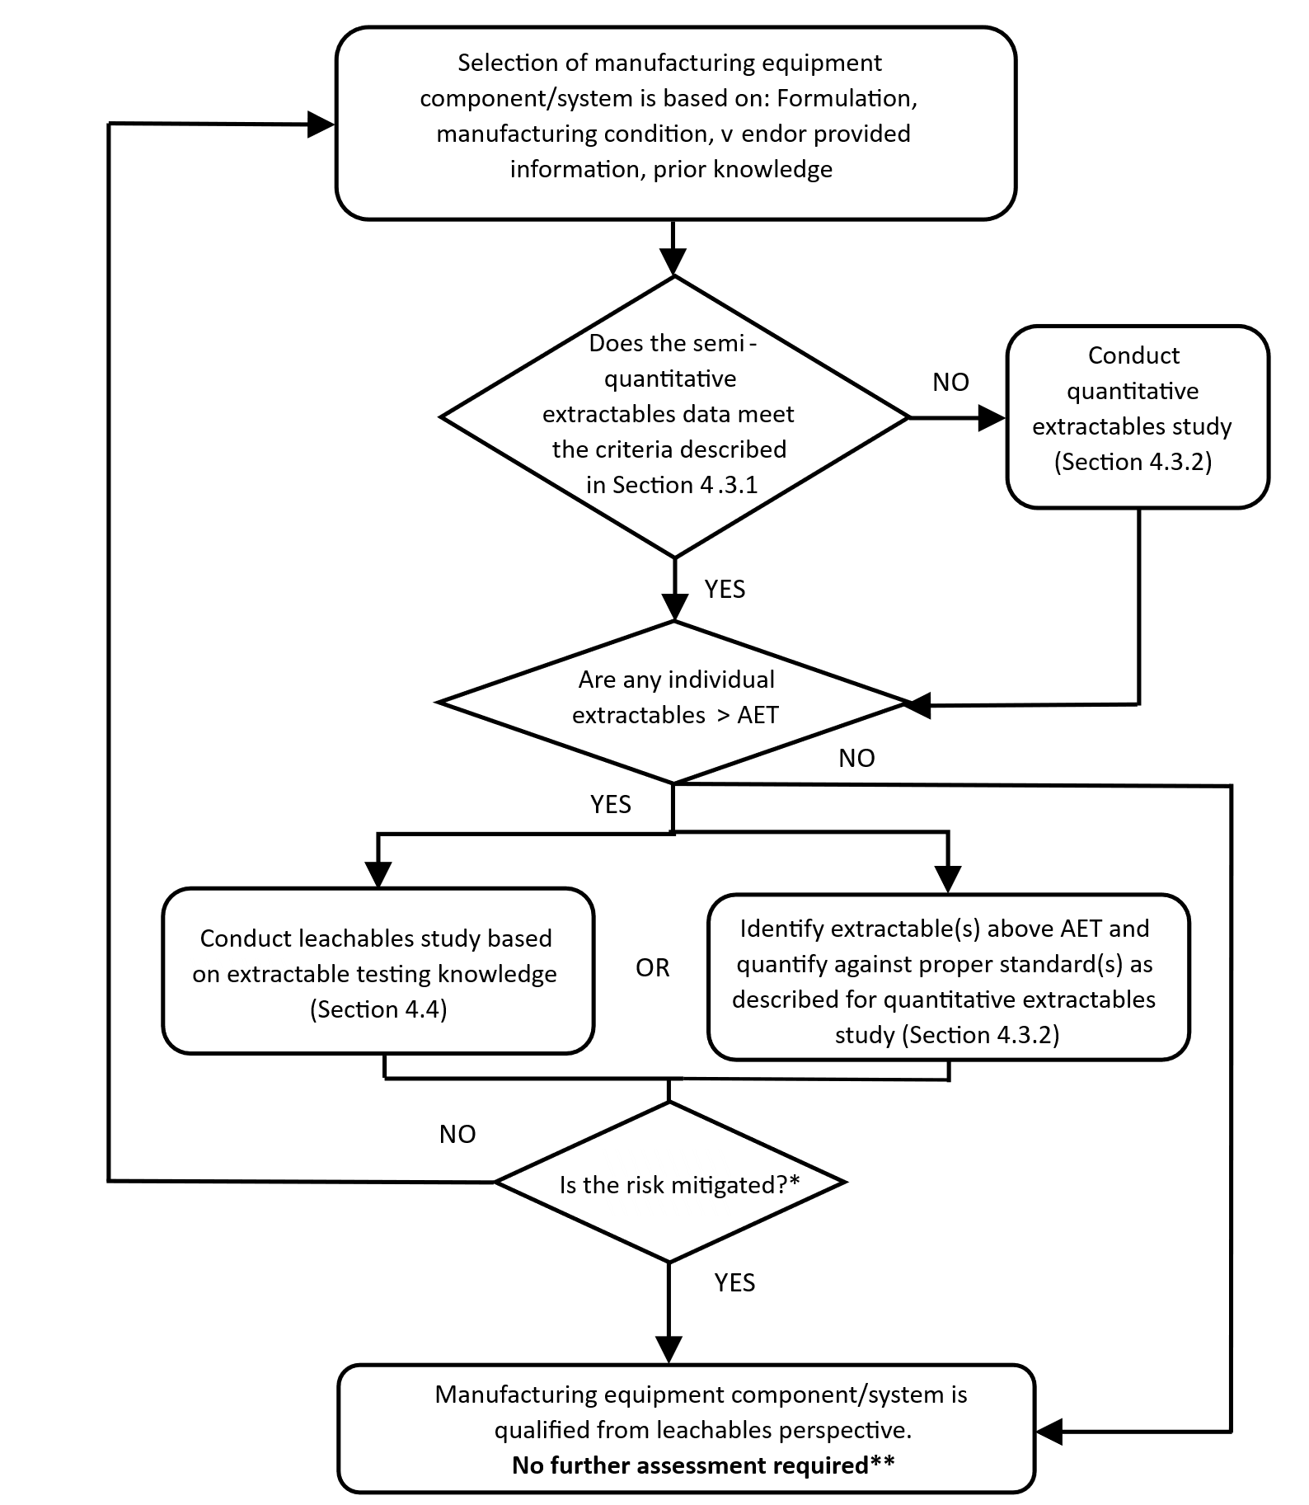

Refer to Section 4.3 for method qualification and chemical identification expectations as well as scenarios where a leachable study is recommended.
* Amount of extractable(s) or leachable(s) are below the applicable safety threshold for each compound.
** For manufacturing process employing multiple components constructed with the same or similar material, cumulative leachables risk should be assessed for the final drug product (see Section 3.4.1).

Figure 5: Typical workflow for E&L assessment related risk identification and mitigation for packaging and delivery device components
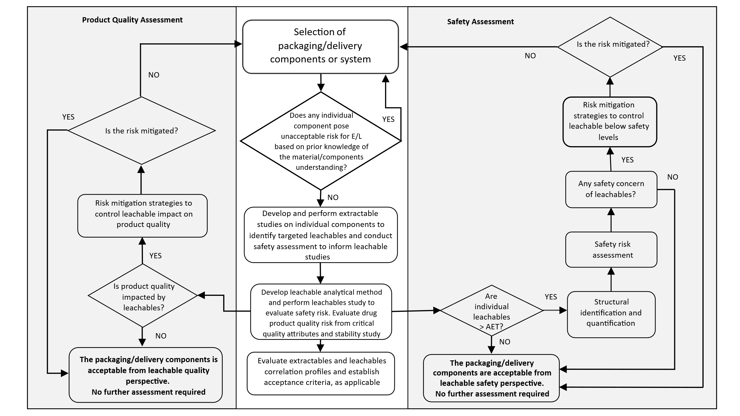

Table A.1.1: Manufacturing Equipment Components/Systems Scenarios
Risk Scenario | Potential Outcome
Scenario 1:  Solid oral drug product manufactured using equipment components compliant with relevant regional food and/or pharmaceutical grade requirements (See Section 3.2). | Components considered qualified without additional extractables or leachables testing.
Scenario 2:  Liquid oral drug product using polymeric manufacturing equipment/systems compliant with relevant regional food-contact safety regulations, use of these materials is consistent with the relevant regulations, and the leaching propensity of the drug product is not greater than identified in the relevant regulation (See Section 3.2). | Components may be considered qualified without additional extractables or leachables testing
Scenario 3:
No manufacturing components/systems extractables above the applicable AET in a semi-quantitative extractable study (See Section 4.3.1).
Scenario 4:  All manufacturing equipment extractables detected, identified, and quantified in the quantitative extractable study above the applicable AET are below their applicable safety threshold (TTC/QT or compound-specific AI/PDE) (See Section 4.3.2). | Components may be considered qualified without additional extractables or leachables testing.

In general, comprehensive extractable and leachable data should be provided for all primary packaging components/systems and delivery device components. However, for overall low-risk scenarios (see Figure 2, Section 3.2) an abbreviated data package that includes a quantitative extractables study may be adequate with justification. See Section 3.4 for situations where a leachable study should be conducted to address the specific concerns and demonstrate acceptability of the components.

Table A.1.2: Examples For Abbreviated Data Package for Packaging and Delivery Device Components
Examples* | Potential Outcome
Example 1:  Container closure system components for oral drug products are compliant with regional food contact regulations including composition, fabrication, specification, testing results, and in-use limitations specified therein (See Section 3.2). | Components may be considered qualified without additional extractables or leachables testing.
Example 2:  Frozen, non-lyophilized drug product stored in a well-characterized packaging system (i.e., prior knowledge provided by the applicant). Drug product is thawed and administered within a short time-period and the duration between initiation of filling and freezing is also short (e.g., < 24 hours) (See Section 3.4.1). | Quantitative extraction studies using appropriate solvent with adequately exaggerated duration may be considered qualified.
Example 3:  Delivery device components with very short/transient contact with oral drug products (e.g., oral syringes, oral dosing cups) are compliant with regional food contact regulations. | Components considered qualified without additional extractables or leachables testing.

Note 1 for Table A.1.1 and Table A.1.2:
Refer to section 4.3 for recommendations for extractable and leachable study, as appropriate.
Refer to section 3.5 for recommendation for appropriate documentation and compliance, as appropriate.
*If no or few extractables are detected above the AET, and below their applicable safety threshold (such as Class 3 leachables; See Section 6), in conjunction with prior knowledge an abbreviated data package may be warranted with adequate justification. When an abbreviated data package is proposed, communications with relevant regional Regulatory Agency/Health Authority is recommended to align on approach.

Appendix 2: Types of Studies
Table A.2.1: Summary of Extractable, Leachable and Simulated Leachable Studies
Study Type | Summary
Extractable | Experimental Conditions:  Employs relatively aggressive conditions incorporating solvents and extraction conditions relevant to the anticipated leaching propensity of the drug product formulation under worst-case conditions to extract a greater number and/or amount of chemical entities than generated under actual-use conditions without inducing a chemical change in chemical entities or material being extracted. Commonly, a range of solvents that are representative of the drug product formulation are used.  Purpose:  Material/component characterization and to provide suitable data for hazard assessment to guide component selection. Under certain low risk scenarios (see Appendix 1), quality risk assessment of extractables may be leveraged for material/component qualification.  Generate chemical entities (potential leachables) that exaggerate (in number and quantity) what will be observed as actual leachables.  Evaluate chemical entities that may practically be expected to leach under intended use conditions.  Identify potential leachables to enable hazard assessment and safety risk assessment as applicable.
Leachable | Experimental Conditions:  Testing of the to-be-marketed drug product over shelf-life and in-use stability. Data may be supplemented with data from drug product using accelerated stability storage conditions if relevant.  Purpose:  Quantify and monitor target leachables over shelf-life and in-use.  Identify and characterize unanticipated (non-target) leachables > AET.  Enable toxicological risk assessment of observed leachables over shelf-life and in-use.
Simulated Leachable | Experimental Conditions:  Testing of the manufacturing components and/or to-be-marketed drug product container closure system with a simulated drug product under conditions that simulate manufacturing and/or long-term storage conditions (pH, temperature, duration). Data may be supplemented using accelerated stability conditions if relevant.  Purpose:  Quantify and monitor target leachables over long-term storage and in-use.  Identify and characterize unanticipated (non-target) leachables > AET.  In rare circumstances when justified and concurred by regional regulatory authority, may be used in lieu of a leachable study for toxicological risk assessment.

Refer to Section 4.3 for detailed recommendations for extractable and leachable study, as appropriate.

Appendix 3 AET Calculations
Each of the examples provided are based upon using the applicable SCT (µg/day) for the drug product. In some instances, an alternative starting point may be pertinent (such as for a potential Class 1 leachable). In all calculations, worst-case assumptions such as maximum approved dosing of the drug product should be assumed. Common examples for both extractables and leachables studies are provided. Calculation of the AET should clearly indicate what the units are and how the calculation was performed. Regardless of the units used to express the AET, the final value for a given study should always equate to the same patient exposure level (i.e., the SCT multiplied by the analytical uncertainty factor [UF]).

Maximum Daily Dose (MDD) and Safety Concern Threshold (SCT)
For each product the calculation of the AET should be based on the MDD. The MDD is the maximum approved dose of a drug administered in a single day.
To determine the SCT, both the TTC and QT should be considered, as indicated in Table 1. The lowest of these values determines the SCT.

Intermittent Dosing
If a drug is not administered every day, for derivation of the applicable TTC ICH M7 is followed (e.g., when total number of dosing days is ≤30, the TTC = 120 µg).
For derivation of the QT, when total number of dosing days is ≤30 days or the dosing frequency is once per month or less, the ≤ 1 month QT can be used.

Multi-day Products
For products that are applied and may remain in place for multiple days (e.g. multi-day patches, depot injections, implants), the applicable TTC is defined by the total duration of treatment. For mutagenic impurities, per ICH M7 an average daily exposure should be used. For non-mutagenic leachable, the default assumption is that all leachables migrate within a day. In this case, the applicable QT is defined by the total number of applications. A slower migration rate would decrease the daily dose to a non-mutagenic leachable but increase the number of dosing days. A slower migration rate should be justified with data.

Example AET Calculations
Extractable Scenario 1: Filter used as part of a manufacturing process for a liquid drug product
- AET (µg/filter) = SCT (µg/day) × UF × Doses per drug product batch* ÷ Filters/batch
- AET (µg/g filter) = AET (µg/filter) ÷ Weight (g)/filter
- AET (µg/mL extraction solvent) = AET (µg/filter) ÷ Extraction solvent (mL)/filter
- AET (µg/cm²) = AET (µg/filter) ÷ Contact surface area (cm²)/filter
*The MDD administered in a single day and the minimum potential batch size should be used to determine the number of doses per drug product batch (i.e., the worst-case scenario). Thus, if the maximum approved dose given in a single day is 100 mg (= 0.1 g) and the minimum potential batch size in 1 kg (= 1000 g), the doses per drug product batch is 1000 g/batch ÷ 0.1 g/dose = 10,000 doses per drug product batch.

Extractable Scenario 2: Rubber vial stopper as part of CCS for a liquid drug product
- AET (µg/stopper) = SCT (µg/day) × UF × Volume/vial (mL/stopper) ÷ Maximum dose in a day (mL)*
- AET (µg/g stopper) = AET (µg/stopper) ÷ Stopper weight (g)
- AET (µg/mL extraction solvent) = AET (µg/stopper) ÷ Extraction solvent (mL)/Stopper
- AET (µg/mL extraction solvent) = AET (µg/g stopper) ÷ Extraction solvent (mL)/gram of Stopper
*The maximum approved volumetric dose administered in a single day should be used (i.e., the worst-case scenario). If dosing is described on a mass basis (e.g., mg/day), it should be converted to a volume (mL) based upon the concentration of the active ingredient. Thus, if the maximum approved dose given in a single day is 100 mg (= 0.1 g) and the concentration of the drug product is 10 mg/mL, the maximum dose in a day for the calculation is 100 mg ÷ 10 mg/mL = 10 mL.

Leachable Scenario 1: Leachables for manufacturing equipment for liquid drug product
- AET (µg/batch) = SCT (µg/day) × UF × Doses per drug product batch*
- AET (µg/mL drug product) = SCT (µg/day) × UF ÷ Maximum dose in a day (mL)
*The MDD administered in a single day and the minimum potential batch size should be used to determine the number of doses per drug product batch (i.e., the worst-case scenario). Thus, if the maximum approved dose given in a single day is 5 mL and the minimum potential batch size in 10 L (= 10,000 mL), the doses per drug product batch is 10,000 mL/batch ÷ 5 mL/dose = 2,000 doses per drug product batch.

Leachable Scenario 2: Leachables for a prefilled syringe (PFS)
- AET (µg/mL drug product) = SCT (µg/day) × UF ÷ Maximum dose in a day (mL)*
- AET (µg/PFS) = AET (µg/mL drug product) × Volume per PFS (mL)
*The maximum approved volumetric dose administered in a single day should be used (i.e., the worst-case scenario). If dosing is described on a mass basis (e.g., mg/day), it should be converted to a volume (mL) based upon the concentration of the active ingredient. Thus, if the maximum approved dose given in a single day is 10 mg and the concentration of the drug product is 10 mg/mL, the maximum dose in a day for the calculation is 10 mg ÷ 10 mg/mL = 1 mL.

Appendix 4: Potency Classes for Leachables
The chemical nature of potential leachable compounds is varied as are their safety databases. In order to remain patient protective while maintaining a practical approach to setting safety thresholds, a leachables classification scheme has been developed, in addition to the thresholds applied in the guideline. The classification scheme is based on systemic effects and is broadly applicable to all routes of administration. However, the concentration thresholds applicable to drug products with specific routes of administration as indicated in Section 6.1 Table 1 are not impacted by this classification scheme. As such, the default concentration thresholds for potential local effects of a leachable are the same regardless of leachable class.
Class 1 leachables are generally those compounds for which the thresholds for mutagenic and systemic effects as described in this guideline have not been demonstrated to be sufficiently patient protective. Thus, for Class 1 leachables an acceptable exposure level should be established on a compound-specific basis. Class 1 includes: ICH M7 cohort of concern compounds, ICH M7 Class 1 compounds with an AI < 1.5 µg/day, and non-mutagenic leachables with a derived Permitted Daily Exposure (PDE) following the methodology described in Appendix 5 for which the established QT values may not be protective of patient safety (see Appendix 6).
Class 2 is the default leachable classification and includes compounds for which the chronic parenteral administration thresholds for mutagenicity (TTC) and systemic toxicity (QT), as described in this guideline, are considered to be sufficiently patient protective. This includes all compounds for which a PDE was not specifically listed in this guideline.
Class 3 leachables are compounds established to have relatively low potency for systemic toxicity with derived chronic parenteral PDE in excess of the levels at which leachables are typically observed. Class 3 leachables would not require further safety qualification if observed at daily exposure levels < 1.0 mg/day.
A summary of these leachables classes is provided in Table A.4.1, below. Leachable levels greater than identified in Table A.4.1 should be scientifically justified as described in Appendix 5.

Table A.4.1: Potency Classes for Leachables
Class 1 – Leachables to be avoided
Mutagens/Predicted Mutagens
Leachables that are part of the ICH M7 cohort of concern (aflatoxin-like-, N-nitroso-, and alkyl-azoxy compounds).
Leachables meeting criteria for ICH M7 Class 1 impurities and an AI < 1.5 µg/day.
Non-mutagens/Predicted Non-Mutagens
Leachables that have a derived parenteral PDE for which the established QT values may not be protective of patient safety (see list below).
ICH Q3E Class 1 leachables should be avoided when practically feasible and exposure should not exceed a scientifically justified compound-specific acceptable exposure level.
Class 2 – Leachables to be limited
Mutagens/Predicted Mutagens
Leachables meeting criteria for ICH M7 Class 1 impurities and an AI ≥ 1.5 µg/day.
Leachables meeting criteria for ICH M7 Class 2 or 3 impurities.
ICH Q3E Class 2 mutagenic (or predicted mutagenic) leachables should not exceed (1) the TTC or less-than-lifetime TTC as appropriate or (2) the QT pertinent to the drug product.
Non-mutagens/Predicted Non-Mutagens
Leachables considered to have a parenteral PDE > QT (excluding those established as Class 3) following the methodology described in Appendix 5.
ICH Q3E Class 2 non-mutagenic (or predicted non-mutagenic) leachables are considered qualified up to the QT pertinent to the drug product without further safety justification.
Class 3 – Leachables with relatively low toxic potential
Non-mutagenic leachables established to have a chronic parenteral PDE in excess of the levels at which leachables are typically observed.
ICH Q3E Class 3 leachables are considered qualified up to 1.0 mg/day or the compound specific PDE (see Table below and Supporting Document) without further safety justification.

Class 1 Leachables to be avoided
Compound | CAS# | Acute Acceptable Exposure Level (µg/day) |  | Chronic PDE (µg/day) |  | Associated Material
Compound | CAS# | Oral | Parenteral | Oral | Parenteral | Associated Material
Benzo(a)pyrene | 50-32-8 | 13 | 1.3 | 2.6 | 0.26 | Carbon black
Bisphenol A | 80-05-7 | 2,083 | 21 | 417 | 4 | Polycarbonate and epoxy resin

Class 3 Leachables With Relatively Low Toxic Potential (Chronic Parenteral PDE ≥ 1 mg/day). Monographs In Supporting Documents.
Compound | CAS# | Chemical Structure
2,6-Di-tert-butyl-4-methylphenol (BHT) | 128-37-0 | 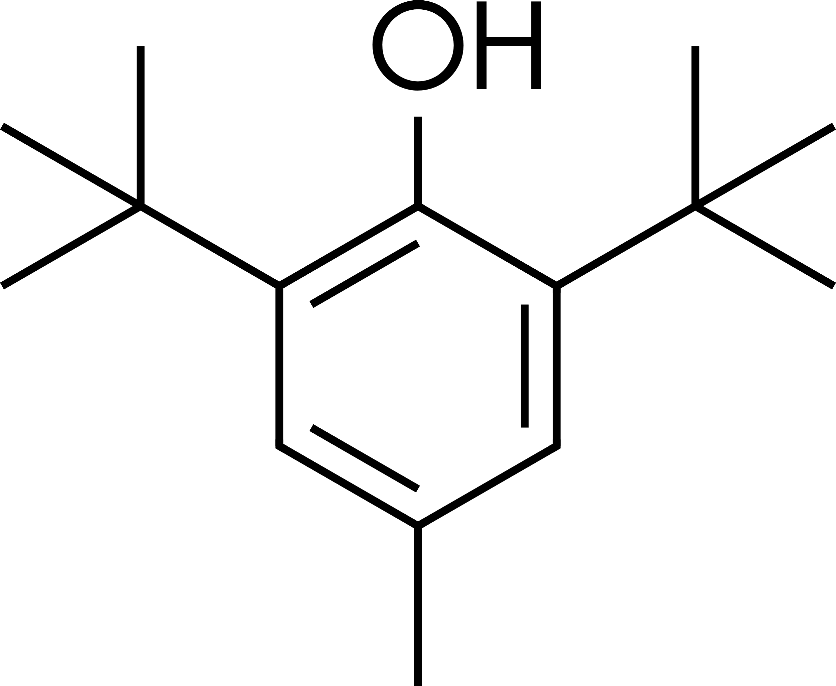
Erucamide | 112-84-5 | 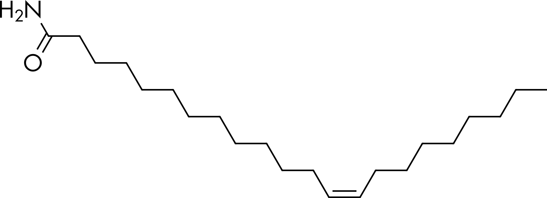
3-(3,5-Di-tert-butyl-4-hydroxyphenyl) propanoic acid | 20170-32-5 | 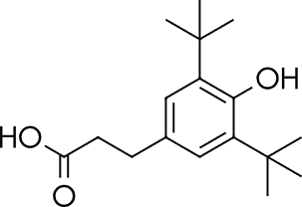
4-Tert Amylphenol | 80-46-6 | 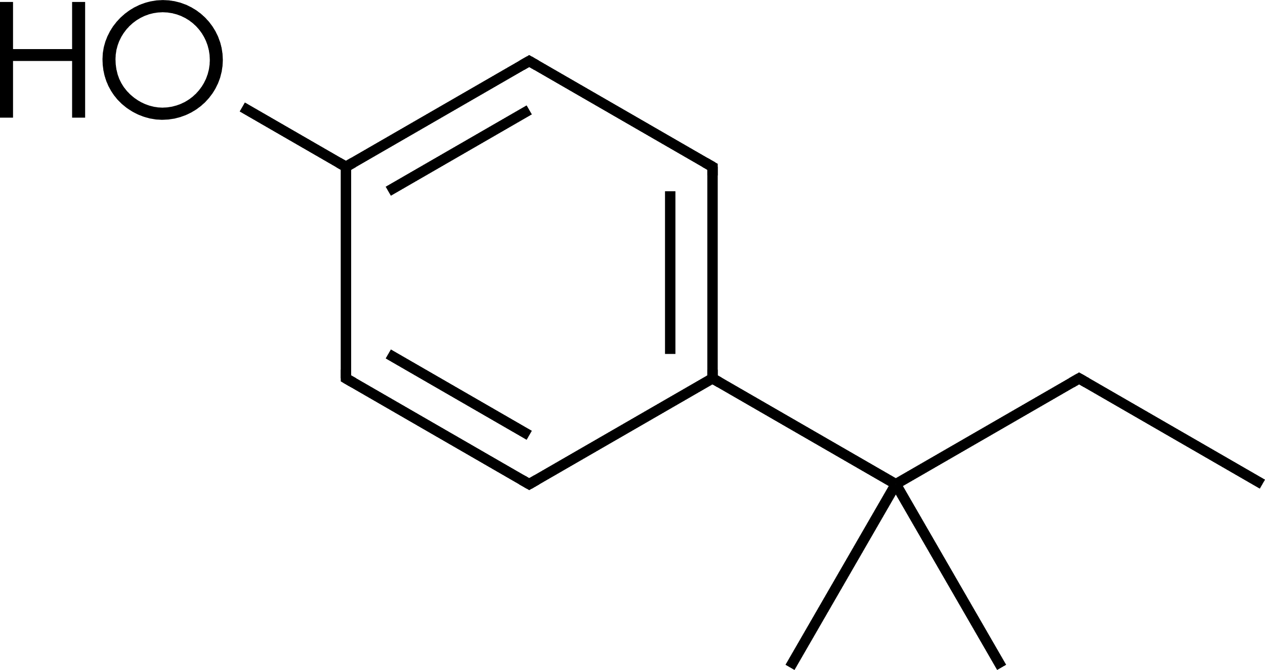
Rubber oligomer C₂₁H₄₀ | 114123-73-8 | 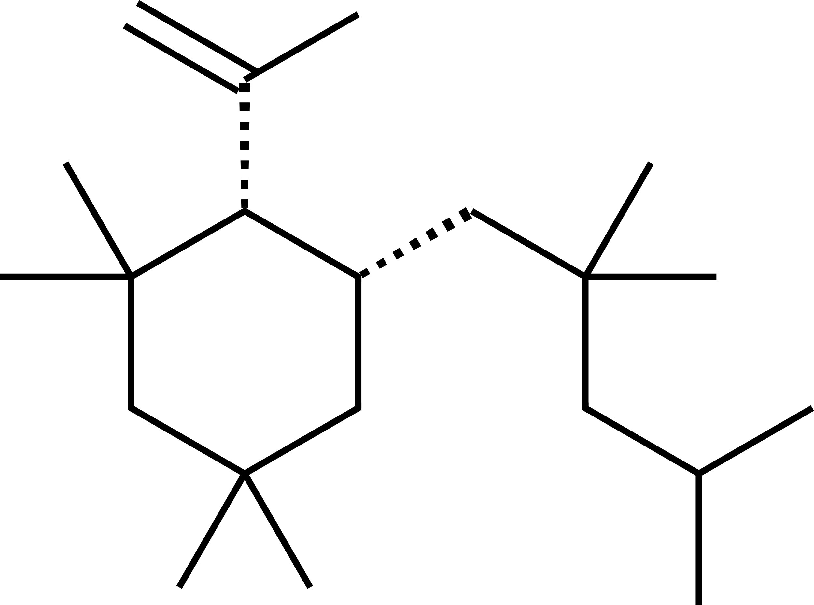
Fatty Acids
Caprylic acid (C8) | 124-07-5 | 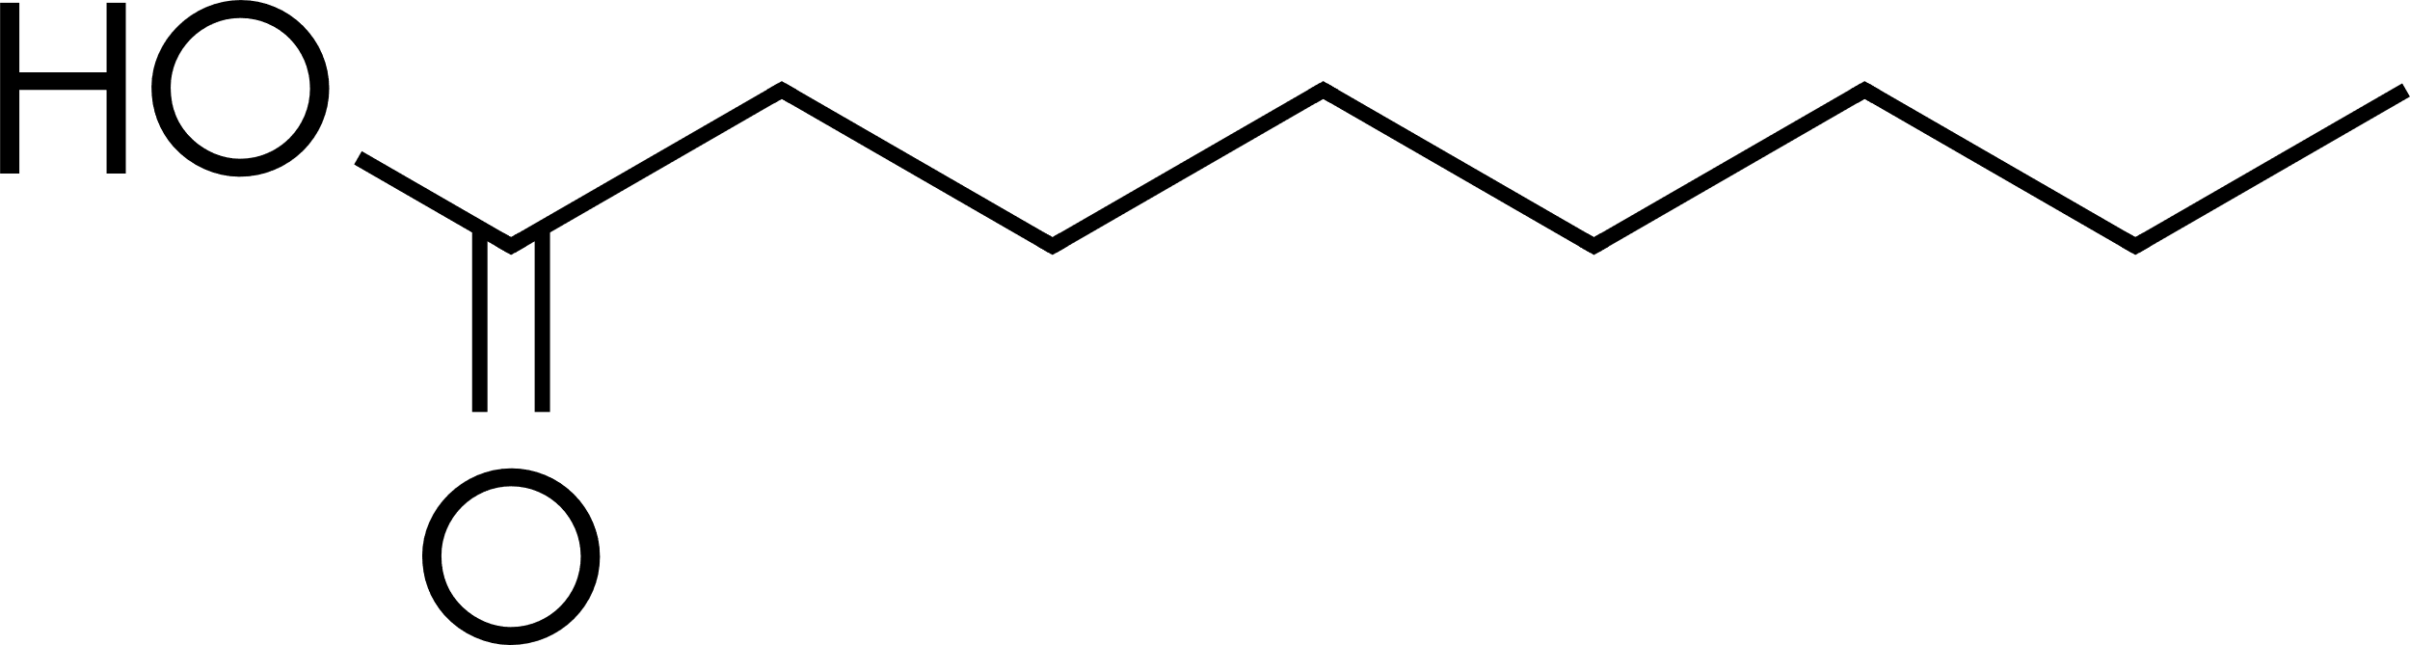
Nonanoic acid (C9) | 112-05-0 | 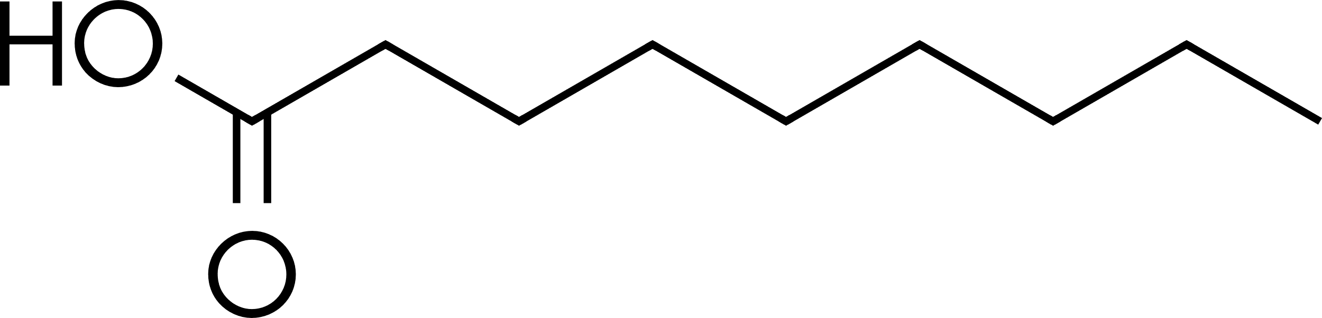
Capric acid (C10) | 334-48-5 | 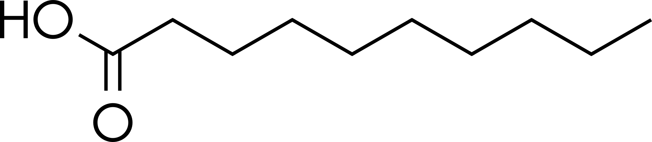
Lauric acid (C12) | 57-10-3 | 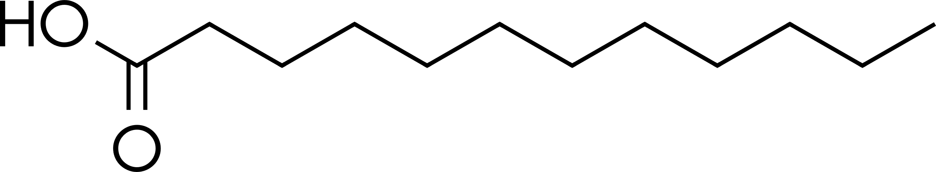
Myristic acid (C14) | 544-63-8 | 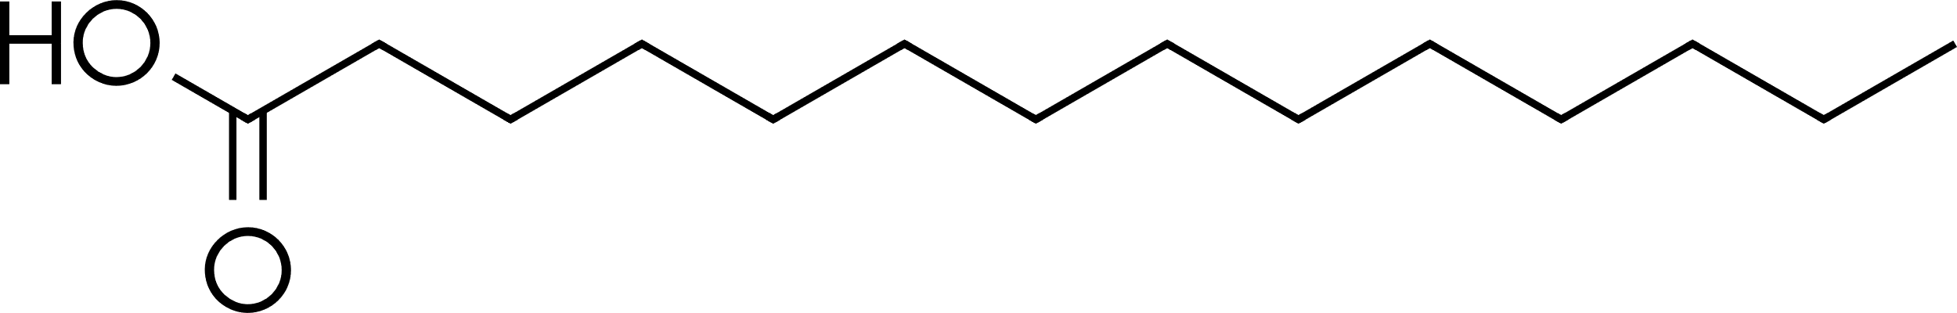
Palmitic acid (C16) | 57-10-3 | 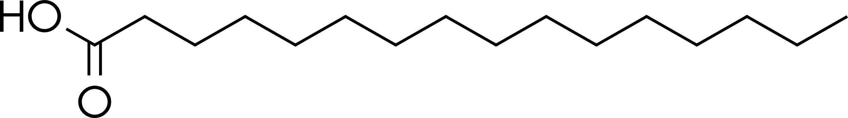
Stearic acid (C18) | 57-11-4 | 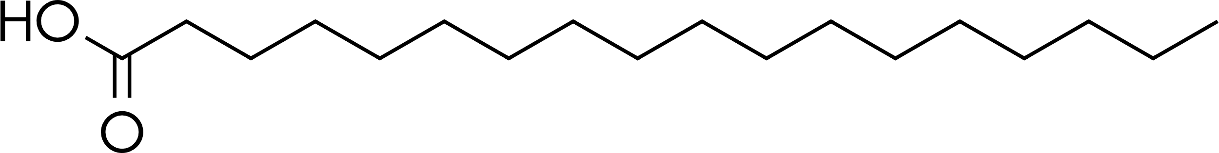
Oleic acid (C18) | 112-80-1 | 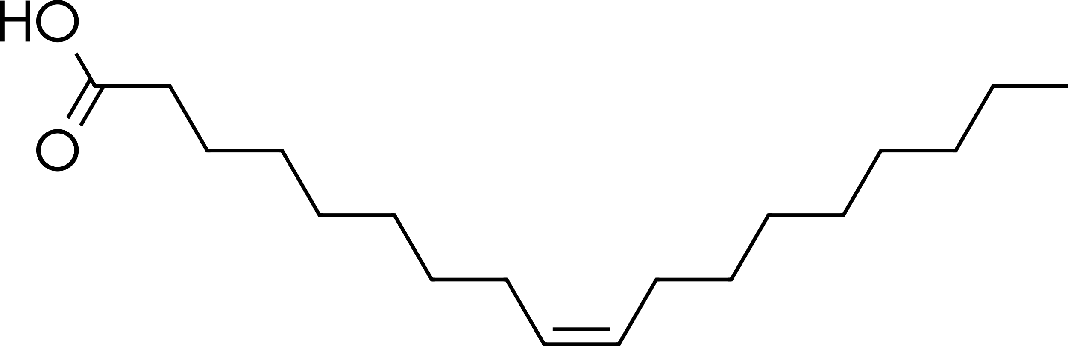
Docosanoic acid (C22) | 112-85-6 | 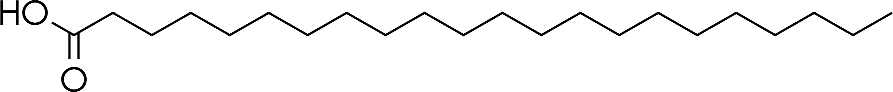

Appendix 5: Methods for Establishing Exposure Limits
Background
For Class 1 leachables and Class 2/3 leachables exceeding their applicable safety threshold as defined in this guideline, further safety assessment is performed to establish the potential risk associated with exposure to these leachables when a patient is administered a specific drug product. Permitted Daily Exposure (PDE) values intended to support safe exposure to a compound in any drug product are not currently established for the vast majority of potential leachables. Furthermore, due to the varied nature of currently available drug products and the complexity of extractables and leachables safety risk assessment, a one size fits all approach, such as an established PDE, is not always most pertinent. Although the focus of this guideline is not on the generation of acceptable exposure levels for individual compounds, the need for compound-specific limits on a product-by-product basis may commonly arise. Therefore, this appendix provides guidance to appropriately establishing the safety of leachables for a variety of drug product types and administration scenarios using a risk-based approach.

The extent of the information considered sufficient to conclude on the acceptability of potential patient exposure levels for a leachable may vary extensively and there are multiple methodologies which may be employed to establish this acceptability. The most straight-forward methodology is to employ already established safe exposure levels which have conservatively assumed worst scenarios. Thus, when there is an established PDE in an available ICH guidance (e.g., Q3C or M7) it is sufficient to refer to this value assuming all requisite considerations are met. Alternatively, an acceptable exposure derived using similar methodologies and scientific principles as previously established in such guidelines may be deemed more applicable or necessary. In still other scenarios, the dose ratio between a well-defined, supported and justified NOAEL and the anticipated patient exposure may be so large (e.g., >10,000) that a detailed derivation may not be necessary.

Though in certain circumstances, in vitro and/or in vivo studies (as a last resort) may be deemed necessary to establish an acceptable exposure level, scientific justification (if applicable) via available in silico analyses and through read across to similar compounds (i.e., surrogate compound[s]) is encouraged to establish acceptable exposure levels.

Although a variety of in silico toxicological tools are available, mutagenicity is the only toxicological endpoint for which such an appropriately conducted evaluation is currently well-established for stand-alone use in lieu of biological data within the context of this guideline (see ICH M7). However, with appropriate scientific justification, predictions of other toxicological endpoints using in silico, in vitro, or in vivo models should be incorporated into the safety risk assessment to supplement any existing data in a weight-of-evidence risk-based approach. Within each of these categories, greater priority should be given to data from validated models that account for the relevant exposure route(s).

Due to the limited nature or even lack of toxicological datasets for a large number of potential leachables, a read-across approach may also be incorporated. In a read-across approach, toxicological data for a surrogate compound (or multiple surrogates) with pertinent toxicological data are used to support the safety assessment of a leachable of interest either as part of a weight-of-evidence approach or in lieu of data for the leachable of interest when none is available. Safety assessments incorporating a surrogate compound should provide clear justification for the selection of the surrogate(s). There are various attributes that should be considered (if known) during the selection of a suitable surrogate, including mode of action, the principal toxicophore and surrounding chemical environment (e.g., presence of functional groups that may impact biological activity), overall structural similarity, toxicokinetic properties, physicochemical properties (e.g., polarity, solubility, ionizability, and molecular weight). When properly justified, in silico tools and data from NAMs may be used to support the selection of surrogates and inform the read-across approach, but the above-mentioned criteria need to be considered. How a surrogate is incorporated into the safety assessment for the leachable of interest should be scientifically justified. Potential uncertainties related to the read-across approach should also be indicated and appropriately accounted for, such as when using for an acceptable exposure level determination (see F7 discussion below).

Data to be Evaluated and Incorporated into the Safety Assessment
In order to establish the safety of a leachable in a specific drug product, a thorough safety assessment of the compound should be provided. Data elements to be included (where data are available) are listed below. The relevance and quality of these datasets should also be assessed. As noted above, any use of surrogate compound data with in silico analyses should also be incorporated into the safety assessment and justified. Additionally, if several observed leachables are grouped together for evaluation, the details and justification of this grouping should be included.
Pharmacological/Biological Data
- Consider available in vivo or in vitro data that suggest the potential for biological effects that could impact the overall safety assessment (e.g., endocrine disruption, anticholinergic activity).
Toxicokinetics (TK)
- Assess and summarize data relevant to the drug product’s route of administration
- Consider potential differences between absorption and bioavailability, especially when route-to-route extrapolations are required.
- Bioaccumulation potential should be considered.
Systemic Toxicity
- Summarize relevant acute, subacute/subchronic and chronic toxicity studies.
- Indicate relevance of data to humans.
- Identify critical study (or studies) for evaluating human systemic toxicity potential.
Sensitization Potential/Local Irritation
- Relevant available clinical and non-clinical data (supplemented with in silico evaluation, if justified) should be summarized.
- Regulatory classifications (or lack thereof) may be leveraged as pertinent.
Developmental and Reproductive Toxicity (DART)
- In addition to summarizing available DART studies, data and/or classifications with respect to endocrine disrupting properties should evaluated and included.
Genotoxicity and Carcinogenicity
- Summarize available data and indicate potential relevance to humans.
- If data are not available, in silico methods consistent with ICH M7 should be used for evaluation (Note: ICH M7 Class 4 is not applicable to leachables).
- Mechanism(s) for genotoxicity and/or carcinogenicity should be provided if applicable as this is particularly pertinent for acceptable exposure determinations.
Additional Information
- Additional pertinent information to the safety assessment should also be included as available.
- Examples: Existing heath-based risk limit/assessments, clinical and epidemiological data, toxicological data from similar/related compounds

Acceptable Exposure Calculations
The PDE concept has been implemented as a health-based exposure limit in ICH guidelines in addition to other health-based limits such as the Acceptable Intake (AI). The process for calculation of a PDE is generally aligned across these guidelines. This same basic approach has been used to generate PDE values in support of the identified qualification thresholds of the current guideline (with the inclusion of additional modifying factors for bioavailability and for when a read-across approach is used). This approach is briefly described and summarized below and may be used as the basis for an acceptable exposure level for a leachable in a specific drug product.

Although the method for deriving an acceptable exposure level described here is based on the PDE methodology described in other ICH guidelines, it should be noted that the acceptable exposure may not necessarily be the same as the PDE. Whereas the PDE is by definition an exposure level for lifetime and is applicable across many products, the product-specific acceptable exposure takes into account the duration of exposure and maximum daily dose. Subsequent to review and evaluation of the available data and information for the leachable as described above, the derivation process begins with the selection of an appropriate point of departure (PoD) and then applying modifying factors (F1–F7). The most relevant study should be used to select the PoD, taking into consideration the species used, the route and duration of exposure, the toxicological endpoints monitored, and the quality of the study data, if justified, it may not always be necessary to select the lowest NO(A)EL as a PoD. Previous guidelines have used specific modifying factors for inter- and intraspecies variability (F1 and F2, respectively), duration of the study from which the PoD is taken (F3), severity of the toxicity (F4), and a factor to account for the absence of a NOAEL (F5). As leachables cover a wide chemical space, bioavailability via various administration routes may vary. Since toxicity data are often only available for a single route, the incorporation of an additional modifying factor (F6) is recommended in the current guideline to account for differences in bioavailability when route-to-route extrapolation is required. Additionally, as noted previously, a PoD from a surrogate compound (read across approach) may also sometimes be necessary. Thus, another modifying factor (F7) to account for uncertainty related to using this surrogate compound is recommended.

As the criteria for selecting values for F1–F5 have been detailed in existing guidelines, they are not repeated here. However, the newly introduced modifying factors (F6 and F7) pertinent to leachables are summarized below.
F6 = A variable factor to account for route of exposure extrapolation (e.g., oral to parenteral).
In the absence of sufficient toxicity data on the leachable via the intended route of exposure of the drug product, F6 should be used to adjust for any pertinent difference in bioavailability between the PoD study route of administration and the drug product route of exposure. Ideally, F6 should be based on bioavailability of the parent compound. If a radiolabel study is used, it should be referred to as absorption because it is not clear if the radiolabel is the parent, a metabolite, or a combination of parent and metabolites. If the quality of data is good, the relative bioavailability estimate can be used to directly inform F6. When there is significant uncertainty for the bioavailability estimate, default factors may alternatively be applied. For example, when using oral toxicity data to derive a parenteral acceptable exposure level:
F6= 100 when oral bioavailability is <1% (divide by a modifying factor of 100)
F6= 10 when oral bioavailability is ≥ 1% and <50% (divide by a modifying factor of 10)
F6= 2 when oral bioavailability is ≥50% and <90% (divide by a modifying factor of 2), and
F6=1 when oral bioavailability is ≥ 90% (divide by a modifying factor of 1)
In the absence of sufficient in vivo data, additional approaches should be employed as part of a weight-of-evidence strategy or in lieu of in vivo data. For example, a NAM approach (combining in vitro data estimating absorption and internal clearance, with an in silico PBPK model) can be used to generate data to assess bioavailability if properly supported and scientifically justified. Alternatively, a default modifying factor of 100 is suggested for F6, with smaller values requiring justification (e.g., reasoning based on the physicochemical characteristics of the compound). When suitable bioavailability data are available for a surrogate molecule allowing a read-across approach these data may be leveraged to inform the bioavailability estimate, if sufficiently justified.
For some routes, such as inhalation, additional considerations are warranted when determining an appropriate F6 value. For example, for an inhalation toxicology study, data on respiratory tract deposition, respiratory absorption rate and pulmonary metabolism may inform on F6.
For dermal routes, if toxicokinetic data are available these can be used to estimate the systemic dose. The parenteral QT can be referred to when evaluating the estimated total daily systemic dose of the leachable. In the absence of toxicokinetic data, when extrapolating from dermal dose to systemic dose, a default absorption of 70% or 50% is assumed to be sufficiently conservative for most organic solvent-based dilutes and water-based or dispersed dilutes, respectively. If both the molecular weight is greater than 500 and the logPow is either below –1 or above 4, a default absorption factor of 10% is assumed. Leachables may penetrate the skin to a greater extent when present in dermal drug products that are formulated for enhanced percutaneous absorption or where skin integrity may be compromised. A higher rate of absorption should be assumed in such cases.
F7= A variable factor that may be applied if a Read Across Approach is used.
When read across strategy is utilized, a factor of up to 5 may be used depending on the level of (dis)similarity to the leachable compound of interest. In general, when a surrogate is considered similar based on the criteria described in this guideline, an F7 of 1 may be applicable.
References
Copies of articles (or other documents) referenced to support a proposed PDE should be provided.
Margin of Safety (MOS) and justification for leachable levels higher than a calculated acceptable exposure level or established PDE
For each substance for which an acceptable exposure level (e.g., PDE or AI) has been determined, a margin of safety can be calculated using the following formula:
Margin of Safety | = | Acceptable exposure level
Margin of Safety | = | Potential patient exposure

For any substances with an MOS <1, risk mitigation measures (such as the selection of alternate materials) that might reduce or eliminate the leachable of concern should be considered. Alternatively, it should be demonstrated that a limit greater than the acceptable exposure level (e.g., PDE) does not pose a safety concern for a specific drug product. An acceptable exposure level to a leachable higher than the calculated or established PDE may be acceptable in certain cases, taking into account relevant product-specific considerations. These cases could include, but are not limited to, the following situations:
- Intermittent administration of the drug to patients;
- Short term administration (i.e., 30 days or less);
- Limited patient population (e.g., adult males only);
- Specific indications (e.g., life-threatening, unmet medical needs, rare diseases).
Additionally, it should be noted, that for drugs administered for less than lifetime to the patient, it may be appropriate to use a lower value for F3 than would usually be applied where a toxicity study of short-term exposure is selected as PoD. In this case an acceptable exposure level is derived, as opposed to PDE. If additional animal studies are available with longer duration, these may have NOAEL values based on findings that may not be relevant to shorter term exposures and therefore may not be the most appropriate PoD for a given drug product. However, while toxicity studies of short-term exposure may be acceptable as a PoD in this circumstance, this does not include LD₅₀ studies.
In cases where a product is administered intermittently, a subfactor approach for F2 as described in ICH Q3D can be applied if supported by data. Alternatively, the value for F3 can be modified.
Table A.5.1: Example considerations for a weight of evidence justification when qualification of leachables is necessary. Non-animal methods should be prioritized where possible.
Toxicological Endpoint | Non-Animal Methods  (with justification) | In vivo Models
General Systemic Toxicity | Read across | Qualification study(ies) as described in ICH Q3A and Q3B  Regional guidance (such as USP)
Local Toxicity | Read across  In vitro models:  Cytotoxicity  (USP <87>, <1031>)  Bovine corneal opacity (BCOP: OECD 437) | Toxicological qualification study(ies) as described in ICH Q3A and Q3B should be considered  Local Tolerance as assessed according to other standards  (such as ISO 10993)
Genotoxicity | In silico models as per ICH M7 | Refer to ICH M7

Appendix 6: Monographs for Class 1 Leachables
Benzo[a]pyrene
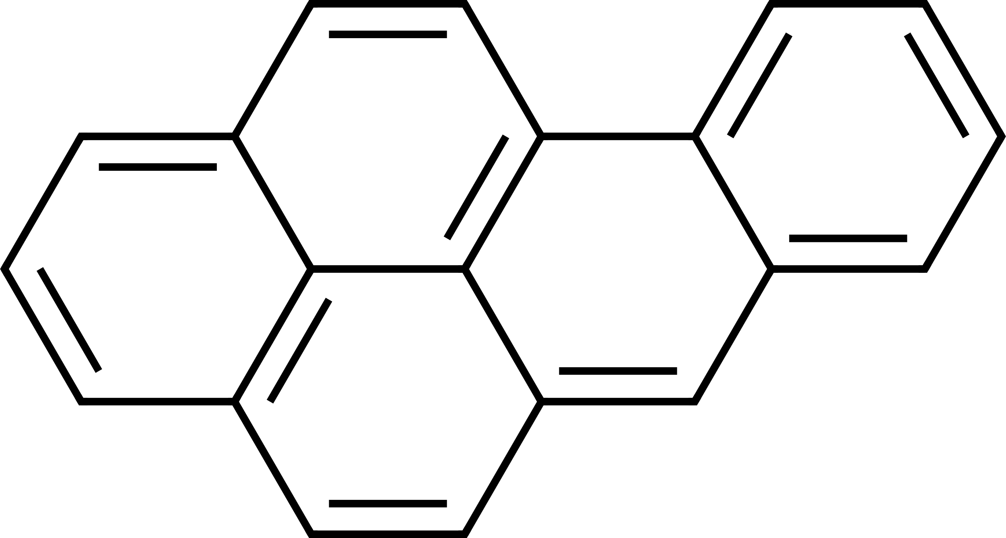
Summary of Acute Acceptable Exposure Level and Chronic PDE Values for Benzo[a]pyrene (CAS# 50-32-8)
Benzo[a]pyrene
Administration Route | Oral (µg/day) | Parenteral (µg/day)
Acute Acceptable Exposure Level* | 13 | 1.3
Chronic PDE | 2.6 | 0.26
*Acute acceptable exposure level is applicable to ≤1-month daily administration
Introduction
Benzo[a]pyrene (BaP) is a polycyclic aromatic hydrocarbon (PAH) consisting of five fused benzene rings. It is not produced or used commercially but is formed as a result of incomplete combustion of organic matter. BaP may leach from materials in which carbon black is present.
BaP is a mutagenic carcinogen and as such, control according to the current version of ICH M7 is appropriate, in addition to the relevant Acceptable Exposure or PDE values derived below. Based on a non-mutagenic endpoint, two oral and two parenteral values for BaP were developed for ICH Q3E.
Safety Summary and Limiting Non-Mutagenic Toxicity
Oral exposure to BaP has been shown to result in developmental toxicity (including developmental neurotoxicity), reproductive toxicity, and immunotoxicity in repeat dose toxicity studies, including adult and juvenile animals. Overall, human studies report toxicological effects that are generally analogous to those observed in animals, and provide qualitative, supportive evidence for hazards associated with BaP exposure.
Based on critical non-mutagenic effects of BaP, the non-GLP oral developmental toxicity study in neonatal rat (Chen et al., 2012) was selected as the PoD study for oral and parenteral PDE derivation.
Oral Acceptable Exposure and PDE
The rat neurodevelopmental study by Chen et al., 2012 administered doses of BaP at 0, 0.02 mg/kg, 0.2 mg/kg, and 2 mg/kg on postnatal day 5 to 11 by oral gavage. Altered responses in three behavioral tests (Morris water maze, elevated plus maze, and open field tests) were selected to represent the critical effect of abnormal behavior, due to the consistency of the observations across groups/studies (i.e., each of these responses were affected in two separate cohorts of rats, including testing as juveniles and as adults; similar effects in these behavioral tests were observed across studies) and sensitivity of these responses, and the observed dose-response relationship of effects across dose groups. Benchmark dose (BMD) modeling for each of the three endpoints resulted in BMD lower bound for 1 standard deviation (BMDL1SD)
values in the range 0.092−0.16 mg/kg-day. Taking the lower end of the range, 0.092 mg/kg-day, was selected to represent the PoD from the neurodevelopmental study.
Oral Calculation
PoD | 0.092 mg/kg/day
BW | 50 kg
F1 (juvenile rat) | 7
F2 (intra-species variability) | 10
F3 (PoD study duration: postnatal day 5 to 11) | 1 for Acute Acceptable Exposure Level
F3 (PoD study duration: postnatal day 5 to 11) | 5 for Chronic PDE critical period of brain development not covered by PoD study.
F4 (Behavioural effects) | 5
F5 (BMDL1SD) | 1
F6 (PoD route extrapolation) | Not applicable
Acute Acceptable Exposure Level = 0.092 mg/kg/day x 50 kg / (7 x 10 x 1 x 5 x 1)
= 0.013 mg x 1,000 µg/mg = 13 µg/day
Chronic PDE = 0.092 mg/kg/day x 50 kg / (7 x 10 x 5 x 5 x 1) = 0.0026 mg x 1,000 µg/mg
= 2.6 µg/day

Parenteral Acceptable Exposure and PDE
In the absence of parenteral administration repeat dose toxicity studies, the same POD study was used to derive the parenteral PDE with the inclusion of a bioavailability modifying factor (F6), based on physiochemical characteristics of BaP (MW = 252.3 g/mol and predicted LogP 3.0 (PubChem, 2024)).
Parenteral Calculation
PoD | 0.092 mg/kg/day
BW | 50 kg
F1 (juvenile rat) | 7
F2 (intra-species variability) | 10
F3 (PoD study duration: postnatal day 5 to 11) | 1 for Acute Acceptable Exposure
F3 (PoD study duration: postnatal day 5 to 11) | 5 for Chronic PDE critical period of brain development not covered by PoD study.
F4 (Behavioural fetal effects) | 5
F5 (BMDL) | 1
F6 (Physicochemical characteristics) | 10
Acute Acceptable Exposure Level = 0.092 mg/kg/day x 50 kg / (7 x 10 x 1 x 5 x 1 x 10) = 0.0013 mg x 1,000 µg/mg = 1.3 µg/day
Chronic PDE = 0.092 mg/kg/day x 50 kg / (7 x 10 x 5 x 5 x 1 x 10) = 0.00026 mg x 1,000 µg/mg = 0.26 µg/day

REFERENCES
International Conference on Harmonisation (2023). M7(R2): Assessment and Control of DNA Reactive (Mutagenic) Impurities in Pharmaceuticals to Limit Potential Carcinogenic Risk.

PubChem (2024) Compound Summary for CID 2336, Benzo[a]pyrene, National Center for Biotechnology Information. Retrieved May 2, 2024, from https://pubchem.ncbi.nlm.nih.gov/compound/Benzo_a_pyrene.

Chen, C; Tang, Y; Jiang, X; Qi, Y; Cheng, S; Qiu, C; et al. (2012). Early postnatal benzo(a)pyrene exposure in Sprague-Dawley rats causes persistent neurobehavioral impairments that emerge postnatally and continue into adolescence and adulthood. Toxicol Sci 125: 248-261. https://academic.oup.com/toxsci/article/125/1/248/1668305.
Bisphenol A

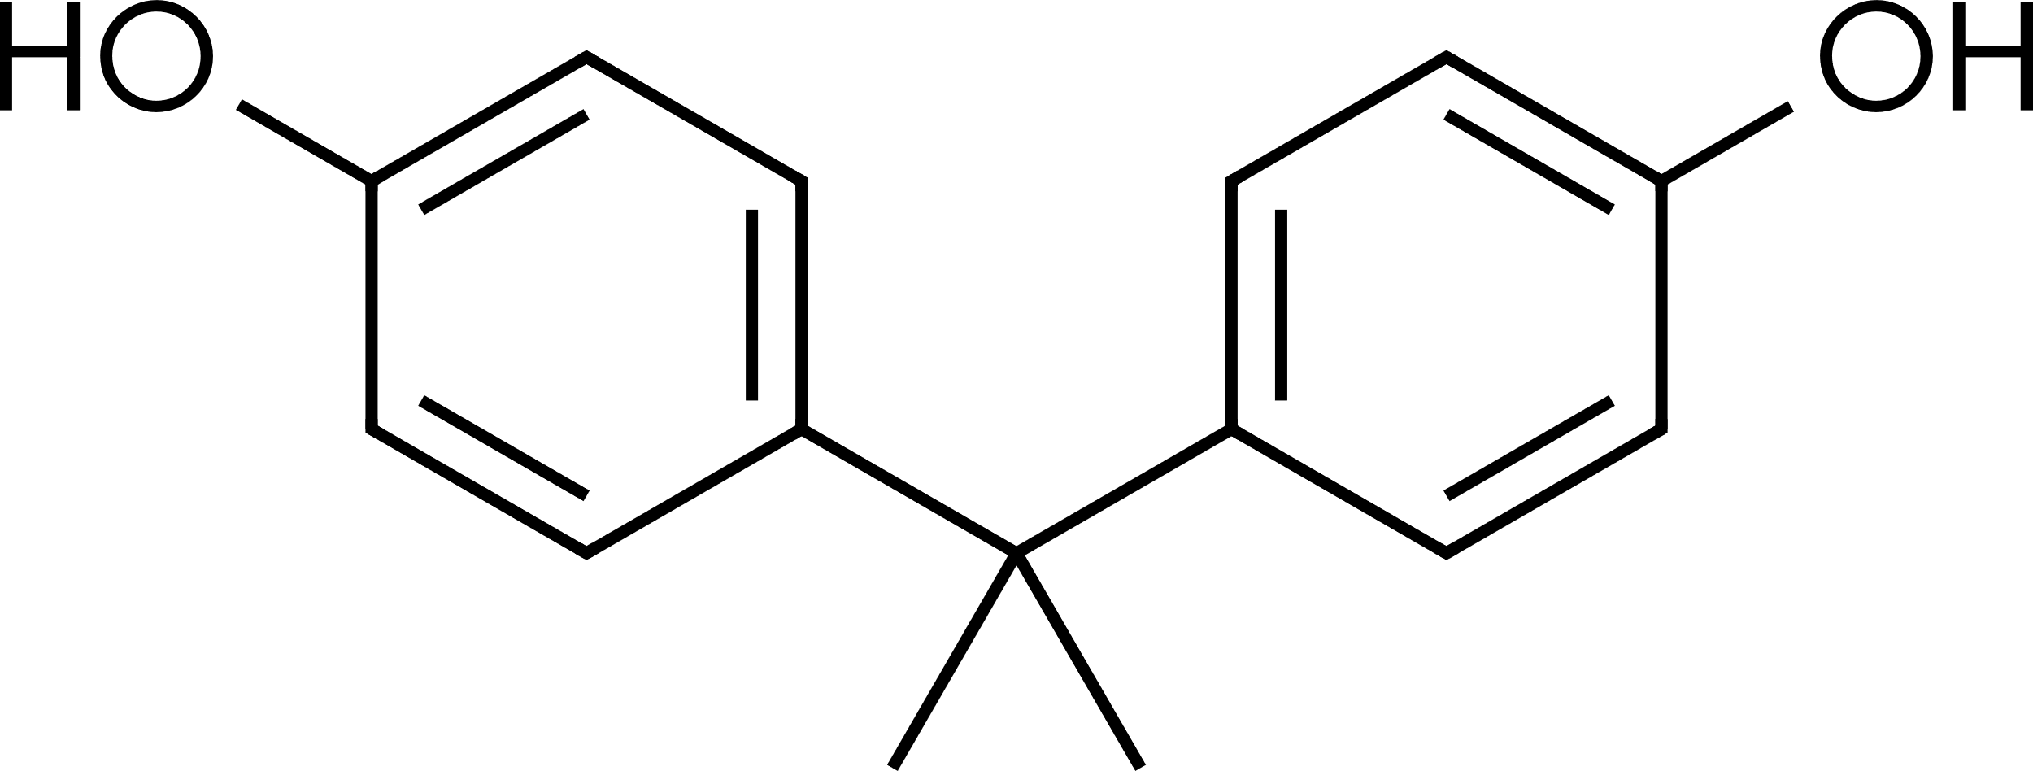
Summary of Acute Acceptable Exposures and Chronic PDE Values for
Bisphenol A (CAS# 80-05-7)
Bisphenol A
Administration Route | Oral (µg/day) | Parenteral (µg/day)
Acute Acceptable Exposure* | 2,100 | 21
Chronic PDE | 420 | 4.2
*Acute Acceptable Exposure value is applicable to ≤1-month daily administration
Introduction
Bisphenol A (BPA) is 4,4'-methanediyldiphenol where the methylene hydrogens are replaced by two methyl groups. It is a key building block of polycarbonate plastic and a precursor for the manufacturing of monomers of epoxy resins. BPA may be present in primary packaging material and manufacturing equipment used in the manufacturing process of medicines, in medicine containers, medicine/device combinations, and in parenteral nutrition bags (Parris et al, 2020).
Safety Summary and Limiting Toxicity
BPA is not mutagenic and non-genotoxic. ECHA listed BPA capable of producing skin sensitization responses in humans and may damage fertility or the unborn child. BPA is not a skin irritant; however, it is irritating to the eye (ECHA, 2024). The European Medicines Agency (EMA) obligates the use of an apical endpoint to minimize uncertainty in relation to human health risk assessment; ICH Q3E is aligned with EMA, and therefore non-mutagenic PDEs were derived for evaluation of BPA as a potential leachable in pharmaceutical products (EFSA EMA, 2023).
Oral Acceptable Exposure and PDE
BPA was tested in a two-generation study in mice (Tyl et al 2008). The GLP and OECD 416-compliant study in mice, evaluated dietary BPA concentrations of 0, 0.018, 0.18, 1.8, 30, 300, or 3500 ppm (approximately 0.003, 0.03, 0.3, 5, 50, or 600 mg/kg/day) ad libitum. Concurrent positive control group of dietary 17β-estradiol (0.5 ppm; 28 per sex) was included to evaluate potential for endocrine disruption.
F0 generation animals received respective formulations in the diet for 8 weeks prior to mating (i.e., until ~14 weeks of age). The animals were then mated for a period of 14 days. Animals continued dosing through gestation (~20 days) and lactation (3 weeks).
No BPA-related effects at any dose were observed for adult mating, fertility or gestational indices, ovarian primordial follicle counts, estrous cyclicity, pre-coital interval, offspring sex ratios or post-natal survival, sperm parameters or reproductive organ weights or histopathology (including the testes and prostate). Systemic effects observed in adults were centrilobular hepatocyte hypertrophy at ≥300 ppm, reduced body weight, increased kidney and liver weights, centrilobular hepatocyte hypertrophy, and renal nephropathy in males. In conclusion, the NOAEL for reproductive toxicity was 300 ppm (~50 mg/kg/day) and NOEL for adult (F0) systemic toxicity was 30 ppm (~5 mg/kg/day).

Oral Calculations
PoD | 5 mg/kg/day
BW | 50 kg
F1 (mouse) | 12
F2 (intra-species variability) | 10
F3 (POD study duration: 4 months) | 1 for Acute Acceptable Exposure
F3 (POD study duration: 4 months) | 5 for Chronic PDE
F4 (No severe toxicity) | 1
F5 (NOEL) | 1
F6 (PoD route extrapolation) | Not applicable
Acute Acceptable Exposure = 5 mg/kg/day x 50 kg / (12 x 10 x 1 x 1 x 1) = 2.1 mg x 1,000 µg/mg = 2,100 µg/day
Chronic PDE = 5 mg/kg/day x 50 kg / (12 x 10 x 5 x 1 x 1) = 0.42 mg x 1,000 µg/mg
= 420 µg/day

Parenteral Acceptable Exposure and PDE
In the absence of parenteral administration repeat dose toxicity studies, the same POD study was used to derive the parenteral PDE with the inclusion of a bioavailability modifying factor (F6). Oral systemic bioavailability of unconjugated BPA of 2.8% in rats and less than 1% in mice, monkey and dogs was reported (ANSES, 2013).

Parenteral Calculation
POD | 5 mg/kg/day
BW | 50 kg
F1 (mouse) | 12
F2 (intra-species variability) | 10
F3 (POD study duration: 4 months) | 1 for Acute Acceptable Exposure
F3 (POD study duration: 4 months) | 5 for Chronic PDE
F4 (No severe effects) | 1
F5 (NOEL) | 1
F6 (Mouse oral bioavailability < 1%) | 100
Acute Acceptable Exposure = 5 mg/kg/day x 50 kg / (12 x 10 x 1 x 1 x 1 x 100) = 0.021 mg x 1,000 µg/mg = 21 µg/day
Chronic PDE = 5 mg/kg/day x 50 kg / (12 x 10 x 5 x 1 x 1 x 100) = 0.0042 mg x 1,000 µg/mg = 4.2 µg/day
REFERENCES
Parris P, Martin EA, Stanard B, Glowienke S, Dolan DG, Li K, et al. Considerations when deriving compound-specific limits for extractables and leachables from pharmaceutical products: Four case studies. Regul Toxicol Pharmacol. 2020 Dec;118:104802.

European Chemicals Agency (ECHA). 4,4'-isopropylidenediphenol. EC number: 201-245-8. CAS number: 80-05-7. Bisphenol A; BPA. Eye irritation. https://echa.europa.eu/registration-dossier/-/registered-dossier/15752/7/4/3. Accessed: April 2024.

German Federal Institute for Risk Assessment (BfR), 2023. Report on diverging views between EFSA and BfR on EFSA updated bisphenol A assessment. https://www.efsa.europa.eu/sites/default/files/2023-04/bfr-efsa-art-30.pdf. Accessed April: 2025.

European Food Safety Authority (EFSA), European Medicines Agency (EMA), 2023. Report on divergent views between EFSA and EMA on EFSA’s updated bisphenol A assessment. https://www.efsa.europa.eu/sites/default/files/2023-04/ema-efsa-article-30.pdf. Accessed April: 2025.

Tyl RW, Myers CB, Marr MC, Sloan CS, Castillo NP, Veselica MM, et al. Two-generation reproductive toxicity study of dietary bisphenol A in CD-1 (Swiss) mice. Toxicol Sci. 2008 Aug;104(2):362-84.

ANSES, 2013. Évaluation des risques du bisphénol A (BPA) pour la santé humaine. https://www.anses.fr/fr/system/files/CHIM2009sa0331Ra-0.pdf. Accessed April: 2025.

